Books

<https://github.com/PacktPublishing/GitHub-Actions-Cookbook>

2 Git Crash Course

3 GitHub Actions - Basic

<https://github.com/qaiser110/ga>

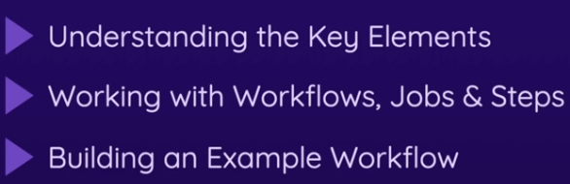



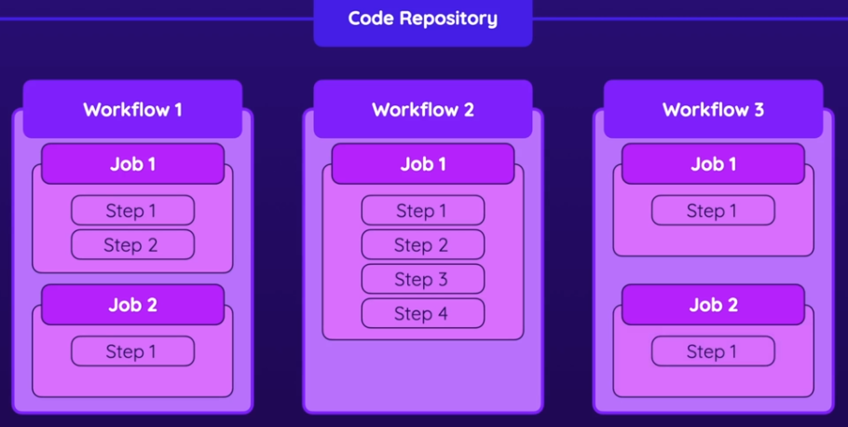

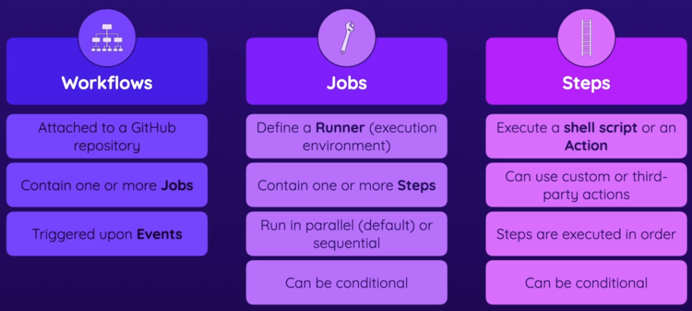

When defining steps, you can either:

* execute scripts or run commands in the shell
* use predefined actions

Here, using the run key, we're defining a command that will be executed in the command line.

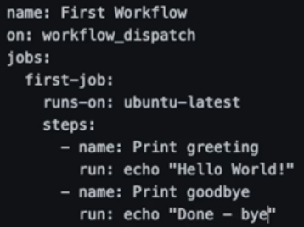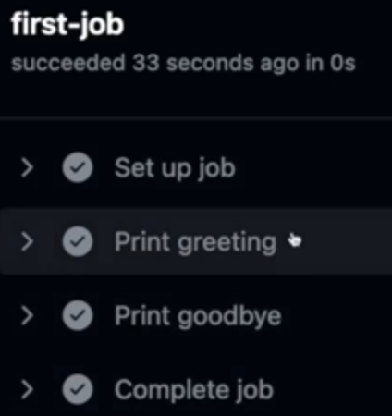

git remote add origin https://qaiser110@github.com/qaiser110/ga.git

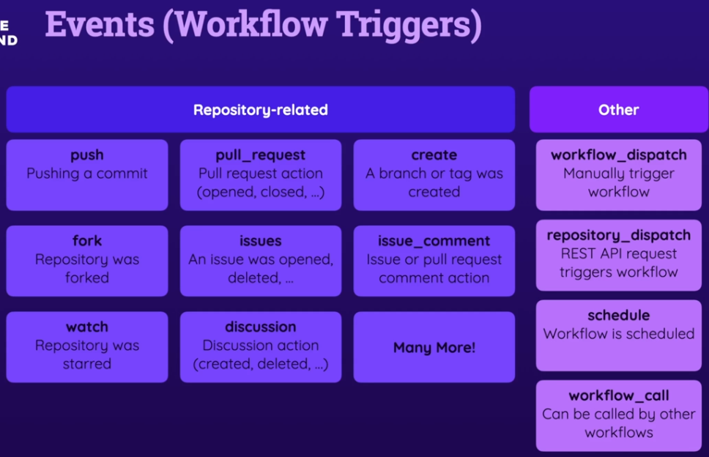

#### GitHub Action vs Command

Actions are another key building block of GitHub Actions. GitHub Action is simply a custom or third-party application that performs a typically complex, frequently repeated task. Like fetching the code from a Git Repo, and downloading it onto such a runner machine. In contrast, a **command** (the "run" keyword in YAML) is mostly a simple shell command on that runner machine, commands written down and defined by us. Now, of course, these commands could in theory also get more complex. You could also run more complex scripts with help of these commands. So it's not always necessarily a simple process that's started with a command, but it will be a command, written by you, in your YAML file. Actions on the other hand, are these predefined applications, which actually also can be distributed through [a marketplace](https://github.com/marketplace?type=actions), because you can build your own Actions, but you can also use official, or community Actions.

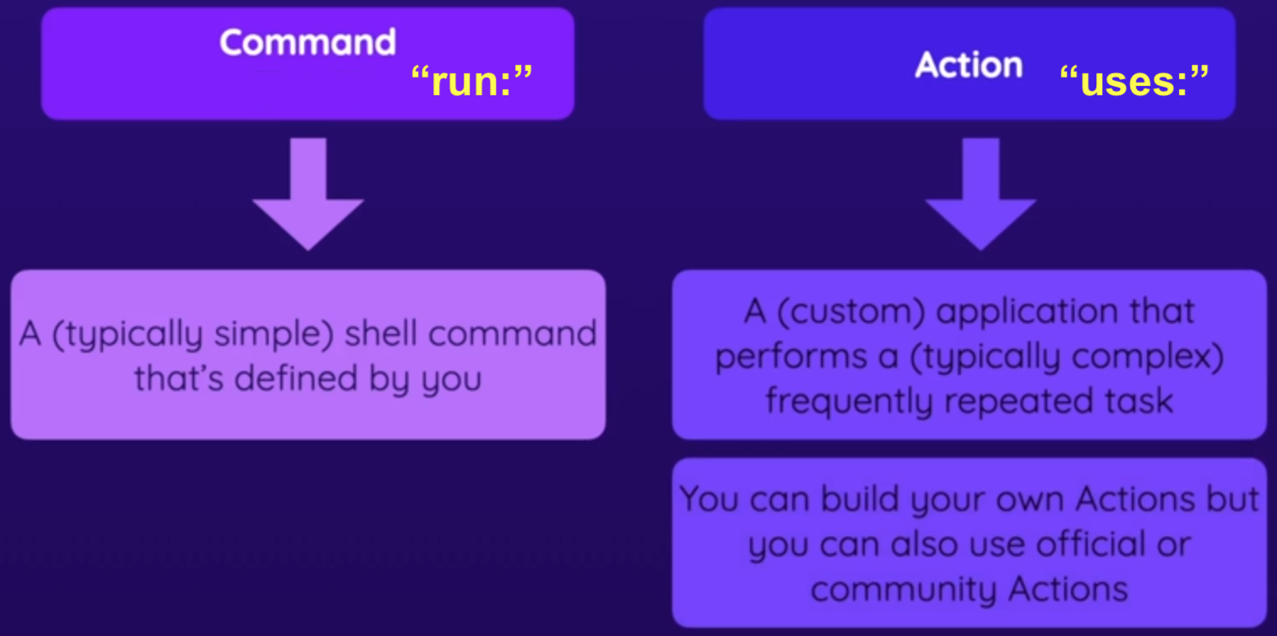

And now here, in our project, I wanna download code from our Repository onto our runner, we can use such an Action. We could write our own **command** that uses Git to clone the code from our repo onto this machine, but since this is a common task, an Action has been created. You can search for [GitHub Action Checkout](https://www.google.com/search?q=GitHub+Action+Checkout) to find [official Checkout Action](https://github.com/actions/checkout)



On the Marketplace, you find [Actions](https://github.com/marketplace?type=actions) and [Apps](https://github.com/marketplace?type=apps). Apps are a different GitHub feature. Docs have the usage instructions:

The difference between command and action is, command is specified with "**run:**" key and command with "uses:" key.

Some actions require some extra configuration, specified with the "**with:**" keyword, along with the "**uses:**" keyword. This "**with:**" keyword then takes various keys that configure the action. And these configs depend on the action. And the official docs have more info. For the checkout action, you can control which GitHub Repository will be used, etc.

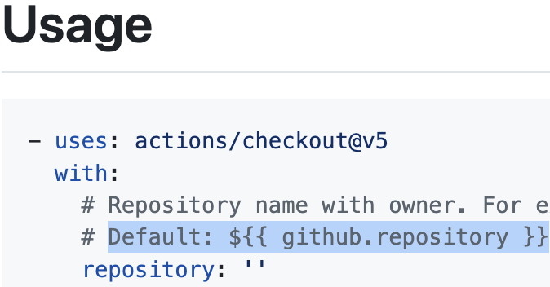 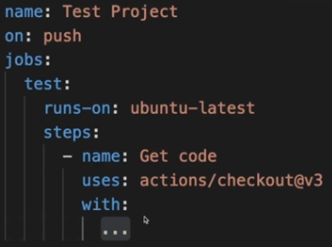

But by default, the Repository to which the Workflow is attached will be used. So we don't need to change this, and we also don't need to change any other settings, but for more advanced usage you could change some settings here. And throughout the course we will of course also dive into some actions that do always need some configuration. Here we could add "**with:**" if we were downloading another repo, but we don't need to since we have our workflow in same repo.

So now, our first step, and this first action will downloaded our current repo since we didn't specify repository:

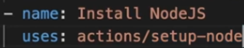 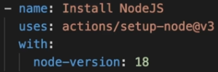

As you can see in official docs, I can add some configuration, like version v3. And we can also provide Node Version we want to install. I'll pick node-version: 18 to make this a bit more meaningful. Because my runner actually has Version 16 installed, so maybe I want that latest version, which at the point of time I'm recording this, is Version 18, so I could indeed install Version 18, like this. Again, technically that's not necessary, but it also doesn't hurt.

### Configuring Actions

It's time for the second step of this job. Our goal is to run the automated tests. For that, we need Node.js installed, and that we install all dependencies of this project. Now, since I'm using **ubuntu-latest**, Node.js is already installed. That's because GitHub publishes a list of preinstalled software on its runners. If you search for [github hosted runners](https://www.google.com/search?q=github+hosted+runners), here on [github-hosted-runners](https://docs.github.com/en/actions/concepts/runners/github-hosted-runners#runner-images), then go to [runner-images](https://github.com/actions/runner-images) link, there you select your runner [ubuntu-latest](https://github.com/actions/runner-images/blob/main/images/ubuntu/Ubuntu2404-Readme.md), and you see a list of preinstalled languages, Runtime, software and tools. And here you see that it comes with Node.js preinstalled.

If we did need to install it though, we could search [github actions install node](https://www.google.com/search?q=github+actions+install+node), we could have added [this step](https://github.com/marketplace/actions/setup-node-js-environment):

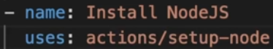

### More Steps

Now for the third step here, I wanna install my dependencies. For this, we just need to run a simple CLI command. And "**npm install**". But "**npm ci**" is better because it uses dependency versions that are locked into **package.lock.json**. It's simply a NPM feature that makes sure that we're always using the exact same versions we used during development. So **npm ci** is a bit safer and makes sure that we don't suddenly install some breaking version.

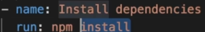 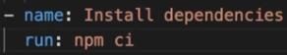

Now one last step, we need **npm test** to run our tests on the runner

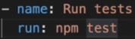

So that's my first job here:

.github/workflows/**test.yml**

name: Test Project

on: push

jobs:

test:

runs-on: ubuntu-latest

steps:

- name: Get code

uses: actions/checkout@v3

- name: Install NodeJS

uses: actions/setup-node@v3

with:

node-version: 18

- name: Install dependencies

run: npm ci

- name: Run tests

run: npm test

And now we can commit. And as I try to push this, I get an error, that I can't push this because the PAT token used for identifying this push request, has no permission to create workflows. It has permission to add code to that repository, but since this specific code will lead to creation of a GitHub action workflow, the PAT token also needs permission for it.

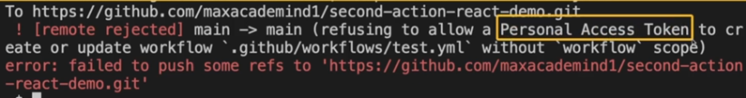

So we have to go to settings of our developer here, and under developer settings down here and personal access token, we have to generate a new token that, in addition to push permissions, also has permission on workflows.

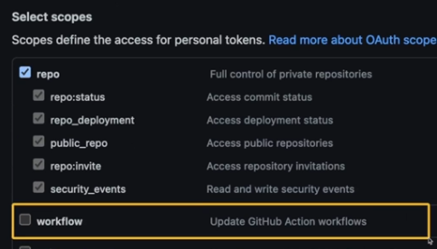

And with that, I can push, and if I go to the **Actions** tab in my github repo, this workflow was added, and it's already executing. Because I set this workflow to run  this workflow is triggered automatically.

### Adding Multiple Jobs

I'll add a second job, which I'll name deploy.

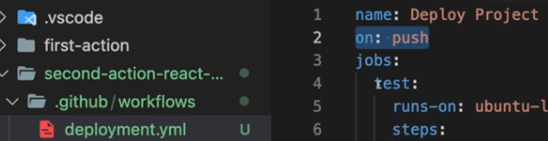

name: Multiple Steps

on: push

jobs:

**test**:

runs-on: ubuntu-latest

steps:

- name: **Get code**

uses: actions/checkout@v3

- name: **Install NodeJS**

uses: actions/setup-node@v3

with:

node-version: 18

- name: **Install dependencies**

run: npm ci

- name: **Run tests**

run: npm test

**deploy**:

runs-on: ubuntu-latest

steps:

- name: **Get code**

uses: actions/checkout@v3

- name: **Install NodeJS**

uses: actions/setup-node@v3

with:

node-version: 18

- name: **Install dependencies**

run: npm ci

- name: **Build Project**

run: npm run build

- name: **Deploy**

run: echo "Deploying..."



git push

We now see both jobs running simultaneously

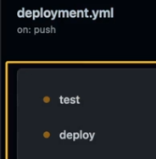

- name: Deploy to GitHub Pages

uses: peaceiris/actions-gh-pages@v3

with:

github_token: ${{ secrets.GITHUB_TOKEN }}

publish_dir: ./build

- name: Deploy

run: exho "Deploying..."

if: github.ref == 'refs/heads/main' && github.event_name == 'push'

### Jobs In Parallel vs Sequential

You can wait for a job to finish by specifying **needs**, so here, we want to wait for the **test** job before running **deploy**

deploy:

needs: test

runs-on: ubuntu-latest

steps:

you could wrap this in brackets to wait for multiple jobs to finish

deploy:

needs: [test, job2]

but here, we only need to wait for the "test" job

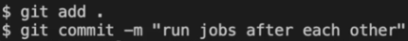

### Using Multiple Triggers (Events)

Let's say, we wanna trigger this Workflow on push, but we also want ability to trigger it manually via **workflow_dispatch**

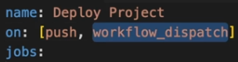

And if I push some changes, I now also have this Run Workflow button, which allows me to trigger it manually.

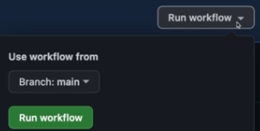

### Expressions & Context Objects

You might have actions or commands that need some env variables. For eg GitHub actions creates some context data with info about the event trigger, the runner and other info that can be accessed inside of these steps. And to see the kind of info you're getting, I'll just output the github object using this syntax.

name: Output information

on: workflow_dispatch

jobs:

info:

runs-on: ubuntu-latest

steps:

- name: **Output Github context**

run: echo "${{ toJson(github) }}"

And here, I wanna access the **github** key, which is one of officially available keys in the context of a **github** job. And to make it readable, I wrap it in a function called **toJSON**, the [toJSON](https://docs.github.com/en/actions/reference/workflows-and-actions/expressions#tojson) expression, which is provided by GitHub.

And this  is called [expressions](https://docs.github.com/en/actions/reference/workflows-and-actions/expressions)

You can look at the different [available github actions contexts](https://docs.github.com/en/actions/reference/workflows-and-actions/contexts).

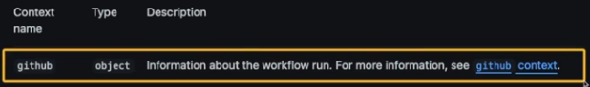

The following example demonstrates how these different types of variables can be used together in a job:

name: CI

on: push

jobs:

prod-check:

if: ${{ github.ref == 'refs/heads/main' }}

runs-on: ubuntu-latest

steps:

**- run:** *echo "Deploying to production server on branch $GITHUB_REF"*

6.11

And if we look at our workflow on github, we see the output:

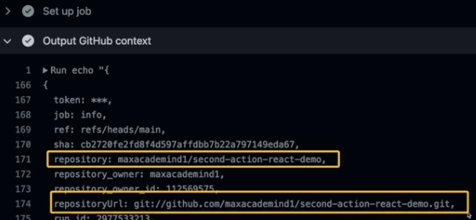

### Module Summary

So we start with workflows, where you define for which events/trigger, which **jobs** should be executed. One Workflow can have one or more **jobs**. With Jobs, you define the environment in which your jobs will be executed. And **steps** are the things that do the actual work. There you **run** CLI commands or you **use** predefined Actions, as you learned. And for the **jobs** you can run them in parallel which is the default or sequential. Now, there are several events either Repository related, for eg, you push and you commit to the repo. But there also are some other events, for eg, that you'd manually start a Workflow. Workflows have at least one event. The Steps of these Jobs then execute on so-called runners which are simply the servers/machines that execute the Jobs, so different runners with Linux, Windows, or macOS.

Now, you can **run** CLI commands, but you can also use Actions, either official Actions provided by GitHub or Actions by other communities, or build your own Actions.

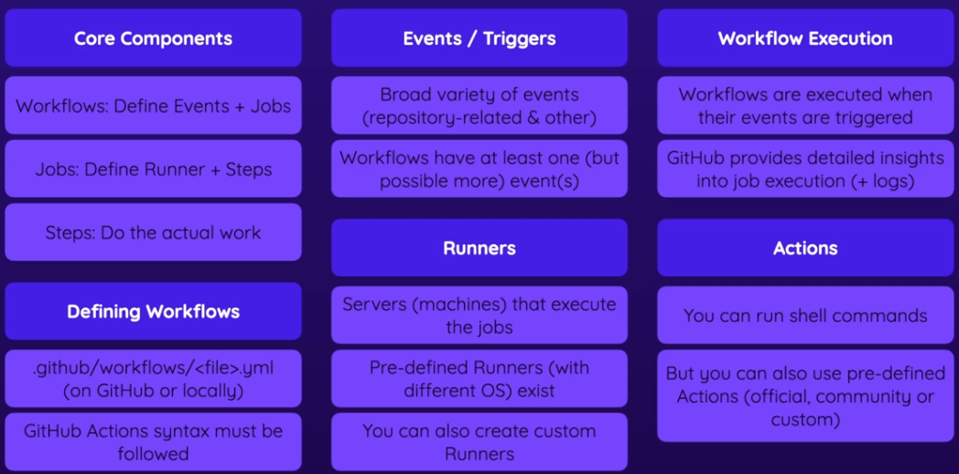

### Lint, Test & Build Workflow

Now we'll create two GitHub Actions Workflows. The first will be one Workflow that lints, tests, and deploys (simulates) the project whenever a new commit is pushed. Both workflows download the project code first and install dependencies. The lint, test & build scripts are included in the package.json file. For this Workflow, we'll create two versions:

* one with the same job for all three scripts.
* one with separate jobs running one after the other

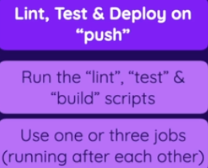

git clone https://github.com/qaiser110/**ghActions_lint_test**.git

Create file:

.github/workflows/1_lint_separate_wf.yml

name: Lint + Test + Deploy

on: workflow_dispatch

jobs:

lint_test_deploy:

runs-on: ubuntu-latest

steps:

- name: Checkout code

uses: actions/checkout@v3

- name: Install dependencies

run: npm ci

- name: Run ESLint

run: npm run lint

- name: Run tests

run: npm test

- name: Build code

run: npm run build

- name: Deploy code

run: echo "Deploying app..."

#### Separate Jobs

.github/workflows/2_lint_separate_wf.yml

name: Lint + Test + Deploy

on: push

jobs:

**lint**:

runs-on: ubuntu-latest

steps:

- name: Checkout code

uses: actions/checkout@v3

- name: Install dependencies

run: npm ci

- name: Run ESLint

run: npm run lint

**test**:

runs-on: ubuntu-latest

**needs**: lint

steps:

- name: Checkout code

uses: actions/checkout@v3

- name: Install dependencies

run: npm ci

- name: Run ESLint

run: npm run lint

- name: Run tests

run: npm test

**deploy**:

runs-on: ubuntu-latest

**needs**: [test, lint]

steps:

- name: Checkout code

uses: actions/checkout@v3

- name: Install dependencies

run: npm ci

- name: Build code

run: npm run build

- name: Deploy code

run: echo "Deploying app..."



### Issues Event Workflow

This Workflow will listen for the Issues Event. Like Push, Issues is one of the official events/triggers you can listen to. There are several Issue related events & action, for eg, when a new Issue is created. And all you should do in that Workflow is output the event details via echo. So we'll listen to the Issues Event and use that GitHub Context Object.

13.28

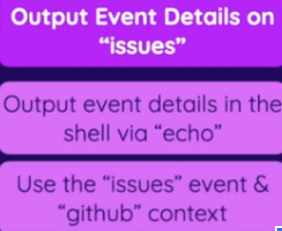

16.12

issues.yml

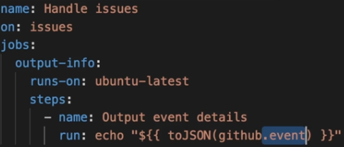

17.16

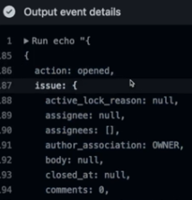

## Events

### Available Events



### Demo Project Setup

.15

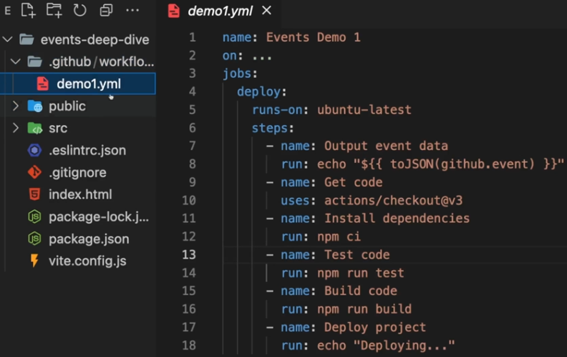

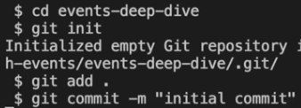

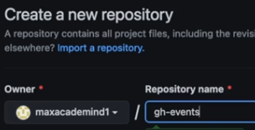



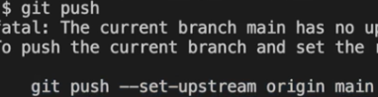

1.11



### 005 Introducing Event Filters & Activity Types

#### Event Types

There are situations where, for eg, you want to trigger a workflow on **push**, but you want more control. Say we wanna trigger the workflow only if **main** branch is targeted. So just adding an event like **push** or pull request alone isn't enough. And GitHub actions gives you more control. For eg, some events have activity types, which allow you to specify in detail which type of event should trigger a workflow. For eg, only if a PR is **opened**, or **closed**, or edited.

#### Filters

And we also have event **filters** supported by some events. Filters exist for the push/pull request events and a few other events. And here we can, for eg, configure that we want to filter all push events, such that only push events that target the **main** branch or any other defined branches will trigger the workflow, and other pushes, which target other branches, won't trigger the workflow.

So, activity types and event filters give us more control over which event exactly will trigger our workflow.

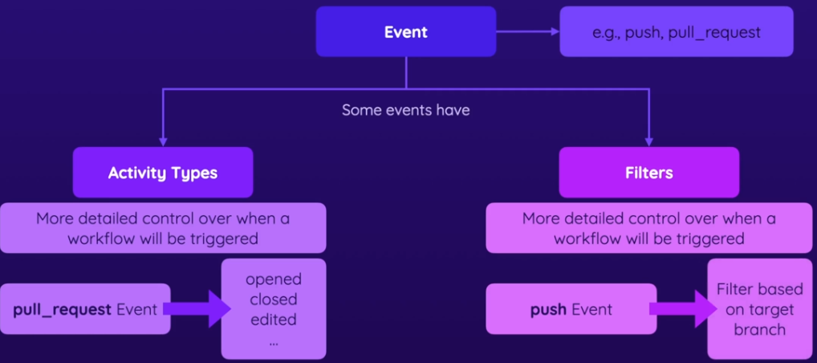

4 Activity Types & Filters

### Using Activity Types

<https://github.com/qaiser110/ghActions_lint_test>

So how do activity types & event filters work? and find which activity types & event filters supported for different events? Well, let's start with activity types. We learn more about those in the official documentation on that page that lists all available events, showing the variations of this event, that can be used for triggering a workflow.

#### Webhook event payload

<https://docs.github.com/en/actions/reference/workflows-and-actions/events-that-trigger-workflows#push>

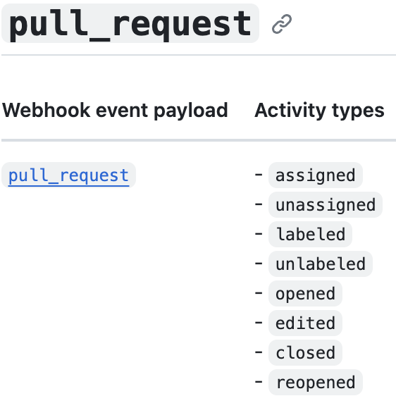

#### Action types

<https://docs.github.com/en/webhooks/webhook-events-and-payloads#pull_request>

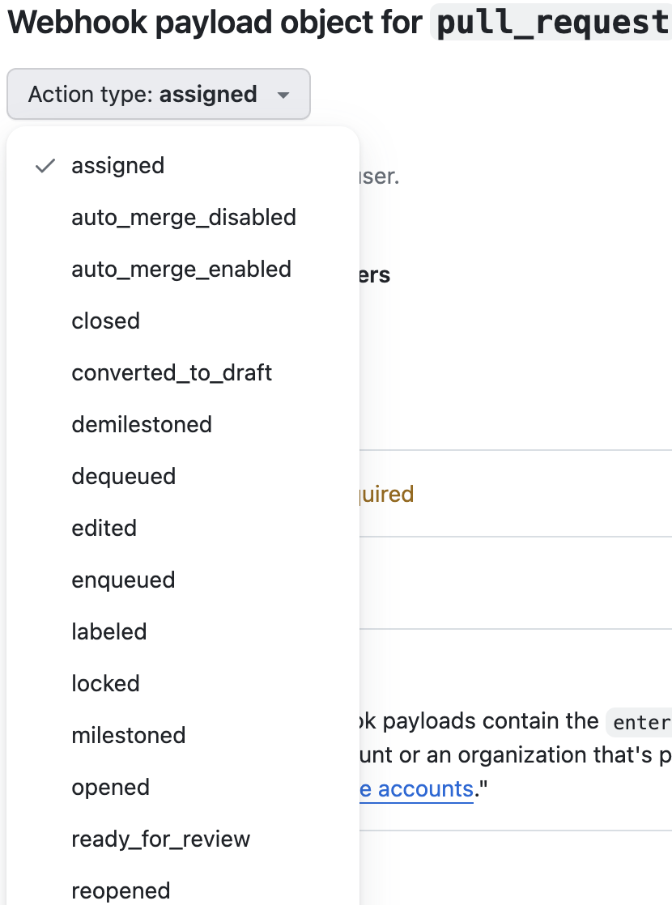

So we can see, for **pull_request** event we have a long list of activity types, but if you don't specify any activity types, by default, **pull_request** event will only activate a workflow when a PR was **opened**, **synchronize** or **reopened**.

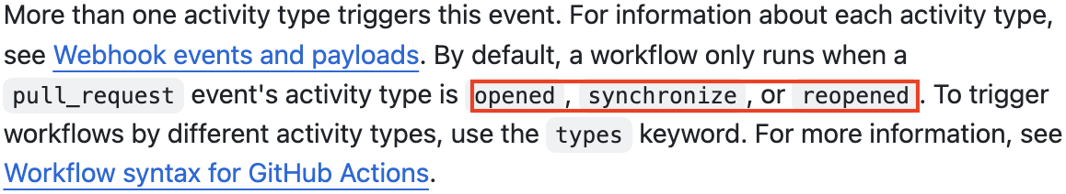

For eg, we want this workflow to trigger when a pull_request is opened or edited.

on:

pull_request:

**types**:

- opened

- edited

And you can also write like this

on:

pull_request:

**types**: [opened, edited]

Now, since we have specific details for the **pull_request** event, if you wanna add a 2nd event, **workflow_dispatch**, we also have to add it like this, at the same level as **pull_request**, even though we got no details for this event.

on:

**pull_request**:

types: [opened, edited]

**workflow_dispatch**:

jobs:

lint:

runs-on: ubuntu-latest

steps:

- name: Checkout code

uses: actions/checkout@v3

**git add .**

**git commit -m "first commit"**

**git push**

Now for the workflow to trigger, a PR needs to be opened, so we'll create a new branch and a new PR:

**git checkout -b new_branch**

Make a small change, changed **h1** to **h2**

<h2>Vite + React</h2>

**git add .**

**git commit -m "changed to h2"**

**git push**

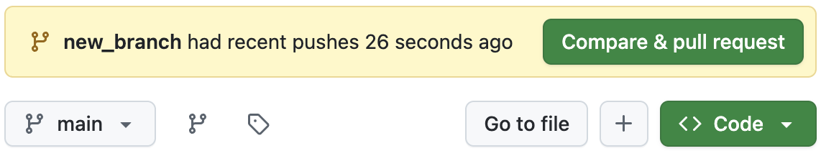

After pushing, you create a PR, that kicks off our workflow:

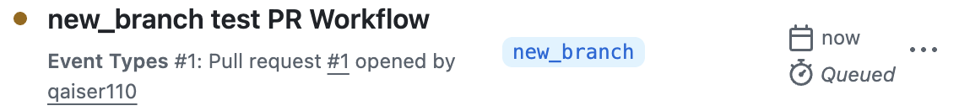

#### Event Context

You can use the event context to further control when jobs in your workflow will run.

For eg, this workflow will run when there is a **review_requested** on a **pull_request**, but the **specific_review_requested** **job** will only run when a review by **octo-team** is requested.

on:

pull_request:

types: [review_requested]

jobs:

specific_review_requested:

runs-on: ubuntu-latest

if: ${{ github.event.requested_team.name == 'octo-team'}}

steps:

- run: echo 'A review from octo-team was requested'

### Using Event Filters

<https://docs.github.com/en/actions/reference/workflows-and-actions/workflow-syntax>





Let's say we wanna listen to the **push** event. By default, a **push** to any **branch** would trigger this workflow.

- name: **Deploy** code

run: echo "**Deploying** app..."

Now, this workflow deploys the code, and you probably don't want to deploy for all pushes on all branches. Instead, you might want only a **push** to the **main** branch to trigger this workflow. You can control that with **event filters**. You can learn more about event filters in docs under workflow syntax. For **push**, we can, for eg, add filter for the **branches**, **tags** or **branches-ignore** or **tags-ignore** filters.



This allows you to only start a workflow if a **push** targets a specific **branch** or **does not** target a specific branch if you wanna check for the opposite or has a specific **tag** attached to it.



So if you want to run it only if a **push** targets the **main** branch, you would add the **branches** filter under the **push** event



So you add this **branches** filter and then specify your list of branches to target, and you can even use a glob pattern. The single asterisk means any characters other than slashes. The double asterisk allows for further slashes as part of the remaining characters. So this would cover pushes to **feat/new** or **feat/ui/button** etc.

push:

branches:

- main

- 'dev-*' # branch starts with 'dev-' eg: dev-new dev-modal

- 'feat/**' # feat/modal feat/ui/button

And **branches** filter can also be added to **pull_request**, also in addition to the **types** here.

on:

pull_request:

types:

- opened

branches:

- main

- 'dev-*' # branch starts with 'dev-' eg: dev-new dev-modal

- 'feat/**' # feat/modal feat/ui/button

So you can add **branches** filter to **pull_request** as you also see in the official docs. And if you know that you wanna run it for all **branches** except a list of specific **branches**, you could use **branches-ignore**. Also for the **push** event.

You can also filter based on file **paths**, so for **push** & **pull_request**, you can add the **paths** & **paths-ignore** filters.

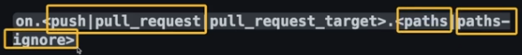

And this allows you to run a workflow if a **push** or **pull_request** changes files in a specific **path** or with **paths-ignore** if you wanna ignore changes in a specific folder. You can see all the syntax, rules for branches and file paths here:

[**Filter pattern cheat sheet**](https://docs.github.com/en/actions/reference/workflows-and-actions/workflow-syntax#filter-pattern-cheat-sheet)

For eg, you wanna run it on push to the **main** branch, except when we change a file in this **github/workflows** folder.

push:

branches:

- main

- 'dev-*' # branch starts with 'dev-' eg: dev-new dev-modal

- 'feat/**' # feat/modal feat/ui/button

paths-ignore:

- '.github/workflows/*'

### Forks & Pull Request Events

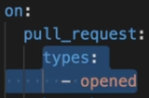

Now, there's one specific thing regarding the pull-request event that you should be aware of, no matter if you're using activity types or event filters. You should be aware of it when you are accepting pull requests from people that forked your Repository. As also covered in the crash course section, people can fork a GitHub Repository, in order to work on the code on their own, and then they can also open pull requests for that. Now, here's something I wanna show you. Keep in mind that this Workflow should run whenever a pull request is opened and that that pull request targets any of these branches. To simulate this as a third-party contributor, so not as the person who owns this Repository, I logged into my second GitHub account here, and I will then grab a link to this Repository and visit it from my second account. That's why I made the Repository public. So now here, I'm on the account that does not own this Repository, and I'll fork it. That's something every user can do. I'll fork it, which means I create a copy here on GitHub and I can then also clone this to my local machine. So now I'm simulating that I'm a different user. Here, I opened this Repository as this second user and now I'll make a tiny change to the code here. In main.jsx, I'll add a comment where I say, "This is important." It doesn't really matter. Now, I made this change and I will store this change in a new branch. Dev-max is my branch name here, but the branch name could be anything. It also doesn't have to be a branch name that qualifies for these filters because these filters are for the branch that's targeted by a pull request, and I created that branch to be used for a pull request in the future. So here I added this, then I will create a commit where I say "added comment" and then I'll push this like this. Now once this is pushed, this update is on my forked GitHub Repository, not on the original Repository, but now I can, of course, create a pull request on that original Repository. So this is now the original Repository and there I can open a new pull request and compare across forks to use my forked Repository as the source. And there this dev-max branch and target the main branch of the original Repository. Now, before I create this, please note that this should qualify for this Workflow. It should trigger this Workflow because it is a pull request. I'm opening a pull request and I'm targeting the main branch. The branch's filter here is always regarding the branch that's being targeted and I'm targeting the main branch. So this Workflow should be executed. So therefore back here, I will now create this pull request, like this, and back in the original Repository, if I refresh my actions page, I have this item here with this exclamation mark. So it looks like the Workflow wanted to run but wasn't really started. Now if we click on it, we see that here we must give approval first. We must first approve that this Workflow should be executed. Now why are we getting this? We are getting this because by default, pull requests based on forks do not trigger a Workflow, even if they technically should. The reason for that is that everyone can fork your public Repositories, and everyone can then create pull requests targeting your Repository. And because of that, people could, of course, start Workflow runs in a malicious way. More on that later in the course in the security section. And they could also simply spam your account and your Repository with Workflow runs by opening dozens or hundreds of pull requests. And even though you are not paying for that if it's a public Repository and you are using the free plan, this could get you into problems, and if you do have a paid GitHub account, it could even cost you money. So that can be a problem and that's why first-time contributors must be approved manually. So whenever first-time contributors, so people who have not opened pull requests before and had those pull requests approved by you before, whenever people open a pull request with your Repository for the first time, you as the owner have to approve that pull request first before the Workflow runs. And then subsequent pull requests will trigger the Workflow automatically because you approved this first pull request manually. So that's how that works. This is not the case if you add a collaborator and that collaborator opened a pull request because the assumption here is that people that were added as a collaborator by you are people you trust, but people you don't know, people who just fork your Repository, those people if they do open pull requests will not automatically trigger your workflows and the workflows will therefore not run automatically. That's something to be aware of.

### Skipping Workflows

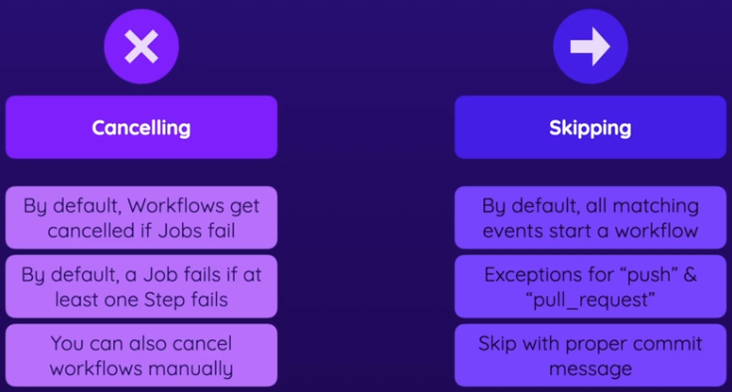

[Skipping workflow runs](https://docs.github.com/actions/managing-workflow-runs/skipping-workflow-runs) - Official Docs

You can skip workflow runs triggered by **push** & **pull_request** events by including a flag in your commit message.

Workflows that would otherwise be triggered using on: push or on: pull_request won't be triggered if you add any of the following strings to the commit message in a push, or the HEAD commit of a pull request:

* **[skip ci]**
* [ci skip]
* [no ci]
* [skip actions]
* [actions skip]

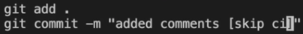

**NOTE:** Skip instructions only apply to push & pull_request events. For eg, adding [skip ci] to a commit message won't stop a workflow that's triggered on: pull_request_target from running.

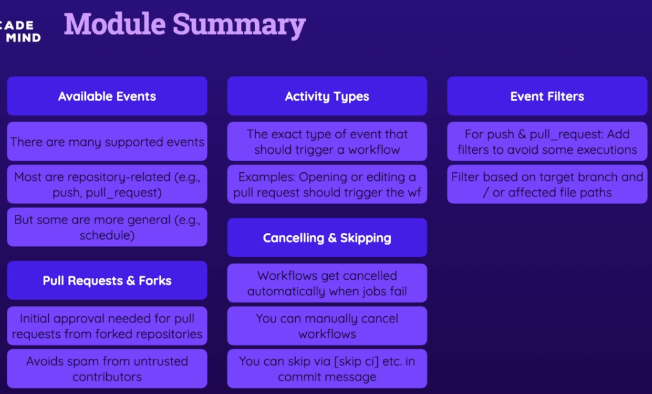

5 Job Artifacts & Outputs

## Job Data, Artifacts & Outputs

<https://github.com/qaiser110/ghActions-Artifacts-Outputs>

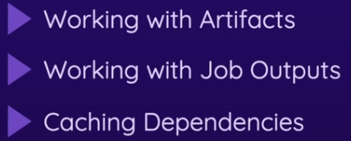

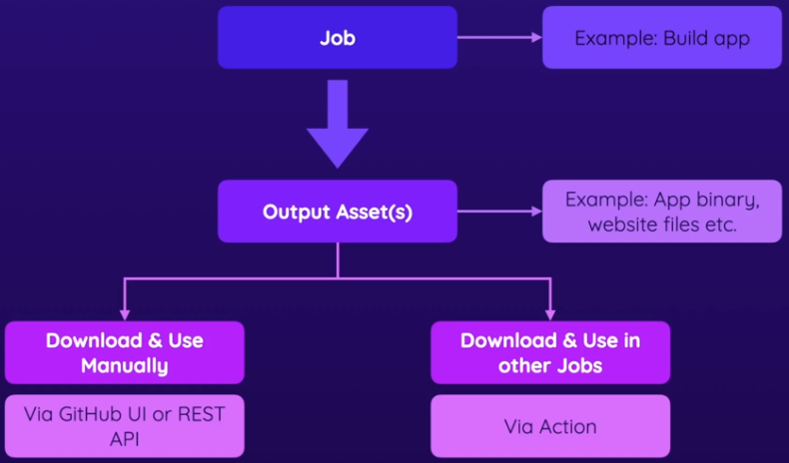

In this section, we'll focus on working with data in our jobs/steps, and using outputs from our jobs. To be precise, we'll explore how we can work with artifacts. Artifacts are to begin with, before we'll then dive into job outputs and learn how they are different from artifacts and explore the concept of dependency caching, another key concept you should know when working with GitHub Actions.

### Demo Project Setup

The project has a finished workflow in the .github/workflows that will be activated on push to the main branch.

I'll git init, and then create initial commit, I'll create a new repo in GitHub, and then I'll will push my main branch.

git init

git add .

git commit -m "first commit"

git branch -M main

git remote add origin https://github.com/qaiser110/ghActions-Artifacts-Outputs.git

git push -u origin main

### What are Job Artifacts

Now, when it comes to working with data, in our GitHub Actions Workflows, there is a broad variety of data definitions. But we'll start with Job Artifacts. Let's take a look at an example Job, that might be building an app. So, this Job could be producing the website files, that are uploaded to a web server, to a web hosting provider. But we could also be building a mobile app, where we then upload some package to the app store. Or we could be producing an executable, which we distribute to our users. So, for eg, a desktop app, that can be executed on their machines.

So, we generate some assets that must be uploaded or distributed somewhere. These assets are commonly referred to as Job Artifacts. It's the output, the assets generated by a Job. And with GitHub Actions, we can upload, and save those artifacts that are produced by a Job, and as the owner of the repo, we may download them manually, for eg, to upload them to app store. But we can also download, and use them automatically in other Jobs. If we have a subsequent Job, that should do something with the produced output. For example, we could have a Job that automatically picks up those produced files, and uploads them to some web hosting provider. So, Job Artifacts are these outputs generated by Jobs.

And it's not necessarily the app binaries, we may have log files that are produced by a testing Job or anything like that. But we're talking about files and folders produced by a Job, that we want to use in other Jobs, or manually inspect after the Job finished. For eg, if we had a job that runs testing scripts, which produce some log files, we might wanna look at those log files, as the repo owner. So, that's what artifacts are.

With GitHub Actions, we have a way of storing these artifacts, so that we can then use them manually, or automatically.

### Artifacts - An Example

Let's look at this demo workflow. It's activated when we **push** to **main** branch. And then we have three jobs: A test job, a build job, and a deploy job. The **test** job gets the code, installs dependencies, and then runs the linting & testing. The **build** job runs after the test job because it **needs** the **test** job. The **build** script will actually produce some output files.

04-Artifacts-Outputs/.github/workflows/demo.yml

| test:  runs-on: ubuntu-latest  steps:  - name: Get code  uses: actions/checkout@v3  - name: Install dependencies  run: npm ci  - name: Lint code  run: npm run lint  - name: Test code  run: npm run test | build:  needs: test  runs-on: ubuntu-latest  steps:  - name: Get code  uses: actions/checkout@v3  - name: Install dependencies  run: npm ci  - name: Build website  run: npm run build | deploy:  needs: build  runs-on: ubuntu-latest  steps:  - name: Deploy  run: echo "Deploying..." |
| --- | --- | --- |

I'll run it locally, and it will produce this **dist** folder to be uploaded to some web server. So that's the build step output.

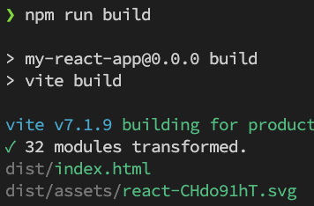 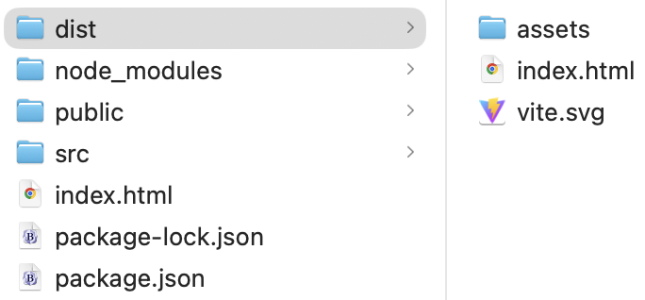

And of course, it would be reasonable to assume that we want access to these produced files, because they don't help us that much if they only live inside of that workflow and on that runner machine. Because once our workflow is finished the runner machine will be shut down and these produced files will be lost. So we wanna store these files, such that we can download them or inspect them locally, or upload somewhere. We also might want to use them in this **deploy** job, but that will be the second step, where we then access those files automatically.

As a first step let's store the artifact produced by this build job, this dist folder, and access them manually. To do this, we can simply add a new step using this [upload-artifact](https://github.com/actions/upload-artifact) action. And we add the **with** key to provide config. I'll give artifacts a **name**. This will be useful for retrieving those artifacts, especially if you want to do that automatically in subsequent jobs. And then we add a **path** to specify where to find the files that are stored. And you can store as many files as you need. You can specify multiple paths, so that multiple files would be organized under a single artifact identifier. And all these files could then be accessed manually or automatically from other steps.

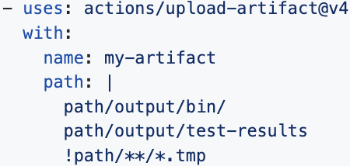 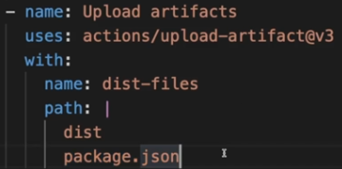

You can also exclude certain paths if you want some files excluded. I just want to store the files in a **dist** folder. But to also simulate how multiple files would be stored and organized, and how to retrieve them, I'll store the package.json file as an artifact as well. This is redundant, I'll do this to see how multiple files and paths could be put into a single artifact.

build:

needs: test

runs-on: ubuntu-latest

steps:

- name: Get code

uses: actions/checkout@v3

- name: Install dependencies

run: npm ci

- name: Build website

run: npm run build

- name: Upload Artifacts

uses: actions/upload-artifact@v3

with:

name: dist-files

path: |

dist

package.json

deploy:

Now, I'll create a new commit and **push**. And you will see the **dist-files** link at the bottom of the executed workflow.

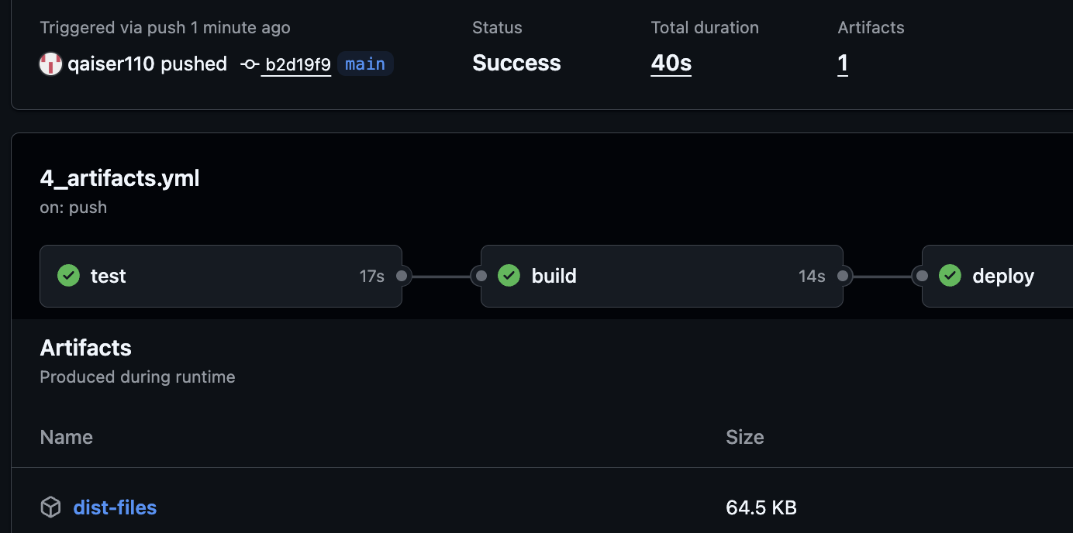

Click the dist-files link to download the zip file and extract

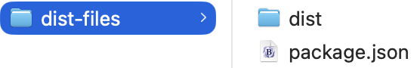

I'll remove package.json since we don't need really need it.

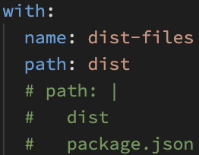

### Downloading Artifacts (Manually & Automatically)

Now, we're generating those files in the build job, and now we wanna use these artifacts in a **deploy** job. Let's assume that instead of printing a message, it really takes those files and stores them on a web server. We'd need a way to get the files produced & uploaded in the previous job, since these **build** & **deploy** jobs run on their own runners, every **job** gets its own runner machine. The files produced in the **build** job will not automatically exist in the **deploy** job because it runs on a different machine.

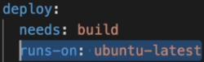 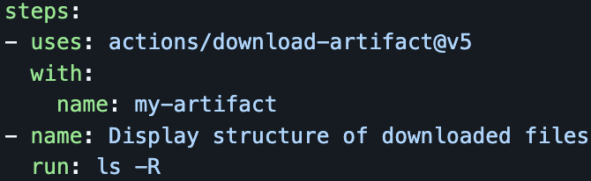

Now, in this **build** job, we need to download the artifacts produced in the previous job. So I'll add a new step, and use the [download-artifact](https://github.com/actions/download-artifact) action. And we have **needs** because **deploy** must run after the **build** job. Now, for this [download artifact](https://github.com/actions/download-artifact) action, we also must specify the **with** key with the artifact identifier. You can upload multiple artifacts in the same job or in different jobs and that's why the identifier is important. And for **name** key, we use the same name as we used for uploading artifacts, **dist-files** in my case.

What this will do is, download and unzip the zip file produced by upload-artifact. So now, **dist-files** will be available in this **deploy** job. Note that we'll lose the **dist** folder, but all the files that were in the dist folder will directly be available here in the folder in which this **deploy** job runs. We can see this if we output the contents here and we run the simple ls command, which lists all the contents of the folder in which we currently are. Let's push to the **main** to see this in action.

deploy:

needs: build

runs-on: ubuntu-latest

steps:

- name: Get build artifacts

uses: actions/download-artifact@v5

with:

name: dist-files

- name: Output contents

run: ls

# - name: Output dist contents

# run: ls -la dist

- name: Deploy

run: echo "Deploying..."

In the **deploy** job, we can see the contents of the dist folder. But we don't see the **dist** folder itself, but instead we have the files themselves. And that's just something to keep in mind when using these files in subsequent steps.

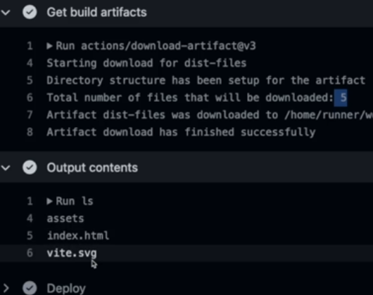

### Understanding Job Outputs

Jobs not only have files/folders as output, but they can also output simple values which can be used by other workflows

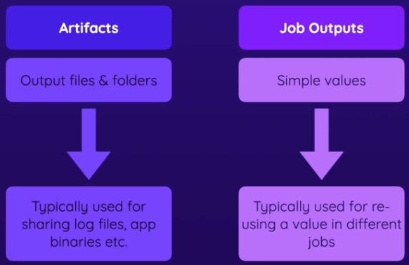

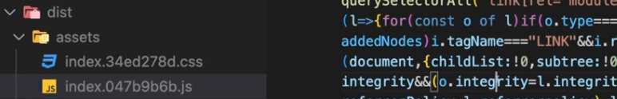

Let's say in the **build** job, where we produce and upload the **dist** folder as an artifact, we also wanna get the name of the generated JS file in this assets folder in the **dist** folder. The js file name is kinda randomly generated. It's not always the same name. Now, we could get that name from the downloaded assets folder in the **deploy** job, but we just wanna show how to work with **outputs**. So let's say here after building the website, we wanna publish the js file name so that other jobs can use it. And for that, we'll run a command that finds the file and then use echo to output that file name. If we run this command on a terminal, it would simply output the file name of this JavaScript file.



So we can use this command after the **build** step

- name: Build website

run: npm run build

- name: Publish JS filename

run: find dist/assets/*.js -type f -execdir echo '{}' ';'

- name: Upload Artifacts

uses: actions/upload-artifact@v4

with:

name: dist-files

path: dist

But to publish the file name to make it available in other jobs, we must create a so-called **output**, which is different from artifacts. An output value is a simple value. So not a file but a number or some text, that should be produced by the job and should be accessible by other jobs. And to generate and share such an output, we must add a new key here at the top level of this job definition before we define the steps. And that's the **outputs** key. Outputs then allows us to define any outputs of our choice, and as many outputs as we want. For example, the **script-file** output.

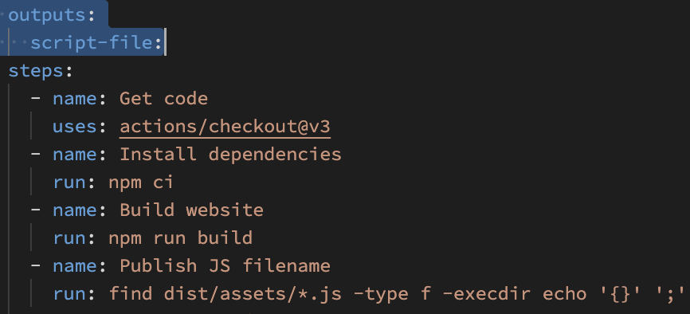

This is the identifier by which you will later be able to access the output value. So here I add my **script-file** output. And now with that added, we're not fully done here but with that added down here, we can set our output.

#### Step & Output

And now to set a step's output value, you first choose an output name, for eg, **MY_FILE**. So as a first step, we're just setting an output name for this step here. We're just producing output of this step and not the whole job. After the name of your step's output, you add an equal signand on the right side of the equal sign, you have the value that should be accessible under that output name. It could be some text but here, but in my case, it's this special placeholder which in the end contains our JavaScript file name.

Now, that's not everything though. You then also have to add two angle brackets and point at **$GITHUB_OUTPUT**. Now, what this **$GITHUB_OUTPUT** does is, it targets a special file created by GitHub in the environment in which your job runs where the output key-value pairis written to.

So this overall commandsimply writes the output to a file, a file whose path is stored in this special variable, **$GITHUB_OUTPUT** which is provided by GitHub Actions. So this simply writes some data into some output file, managed by GitHub. And that then overall sets the output for this step.

#### Job Output

But we wanna set an output for the job, not just for the step. We'll give our step a unique ID so we can identify this step

- name: Publish JS filename

id: publish

run: find dist/assets/*.js -type f -execdir echo '**MY_FILE**={}' >> $GITHUB_OUTPUT ';'

So now, to set an output for the job, we'll use the special **steps** context value made available by GitHub Actions. And we identify the step from the unique ID **publish**. And then outputs, then the step's output name, **MY_FILE**

build:

needs: test

runs-on: ubuntu-latest

**outputs**:

script-file: ${{ steps.publish.outputs.**MY_FILE** }}

steps:

- name: Get code

uses: actions/checkout@v3

- name: Install dependencies

run: npm ci

- name: Build website

run: npm run build

- name: Publish JS filename

id: publish

run: find dist/assets/*.js -type f -execdir echo '**MY_FILE**={}' >> $GITHUB_OUTPUT ';'

- name: Upload Artifacts

uses: actions/upload-artifact@v4

with:

name: dist-files

path: dist

Now that sets the output from the **build** step.

### Using Job Outputs In Other Jobs

So we published an output in **build**. To use it in **deploy** job, we add a new **step** where I execute a run command that uses the output by the **build** job. And here I simply wanna output that file name to keep things simple.

jobs:

build:

needs: test

runs-on: ubuntu-latest

**outputs**:

script-file: ${{ steps.publish.outputs.MY_FILE }}

steps:

- name: Get code

uses: actions/checkout@v3

- name: Install dependencies

run: npm ci

- name: Build website

run: npm run build

- name: Publish JS filename

id: publish

run: find dist/assets/*.js -type f -execdir echo 'MY_FILE={}' >> $GITHUB_OUTPUT ';'

- name: Upload Artifacts

uses: actions/upload-artifact@v4

with:

name: dist-files

path: dist

# path: |

# dist

# package.json

deploy:

needs: build

runs-on: ubuntu-latest

steps:

- name: Output filename

run: echo "Built file ${{ needs.build.**outputs**.script-file }}"

Now, we could get data about other jobs with help of the **jobs** context object. But for outputs, a better object to use is the **needs** object. And if we push our changes, we'll see this output:

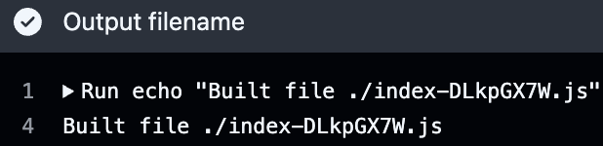

### Caching Dependencies

I have three jobs running after each other. Since they're not running in parallel, it's the sum of the jobs that's taken to complete the workflow. Now, running the jobs in parallel isn't an option because these jobs depend on each other.

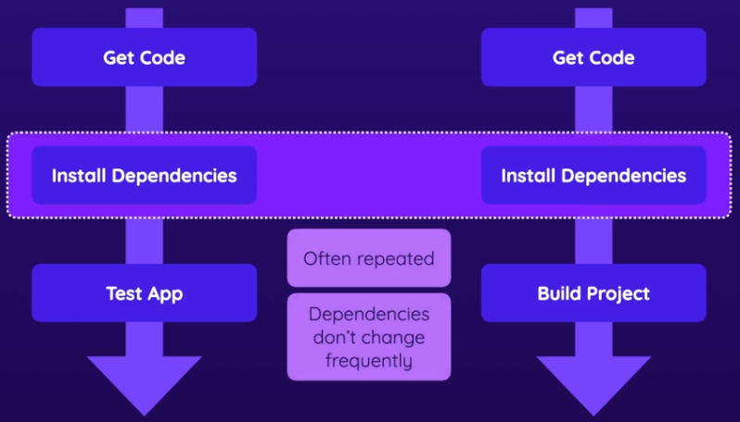

If we take a look at the workflow definition file, you'll notice that there are some repeated steps. For eg, getting the code & installing the dependencies. Now getting the code is needed in every job since every job runs on its own runner. But installing dependencies is the step that takes the longest. So if we can shorten this step, we could save a lot of time.

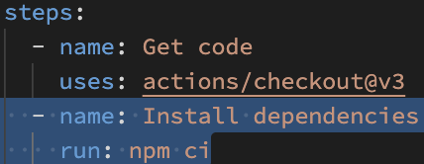

It's pretty common that you have some step like the dependency installation step we have at here. Very often you must install third party dependencies or run some setup scripts that generate some files. This is pretty common for most CI/CD workflows. And a great way of speeding up that installation process for those dependencies is to cache those dependencies. Because if you got two workflows that do different things but have this shared step of installing dependencies, which tends to take a bit longer and which produces files that are needed by the other steps in the jobs, if you have something like this, then it makes sense to only install those dependencies once in one job and then cache them so that other jobs can reuse those cached dependencies. Because those dependencies typically don't change frequently and therefore you can save time if you do cache them so that the cached dependencies can be reused thereafter instead of being downloaded again, which is the part that takes rather long. And it's not just caching across different jobs that matters here, you can actually also cache dependencies or files and folders in general across workflow executions, because if you have certain files and folders that don't change at all across different workflows, it makes sense to cache them across different workflows so that they don't have to be re-downloaded or recreated all the time. And this is such a common scenario that GitHub Actions has an official action that helps with caching files and folders across jobs and workflows. And it's this cache action which we're going to use now.

[docs.github.com/actions/dependency-caching#example](https://docs.github.com/en/actions/reference/workflows-and-actions/dependency-caching#example-using-the-cache-action)

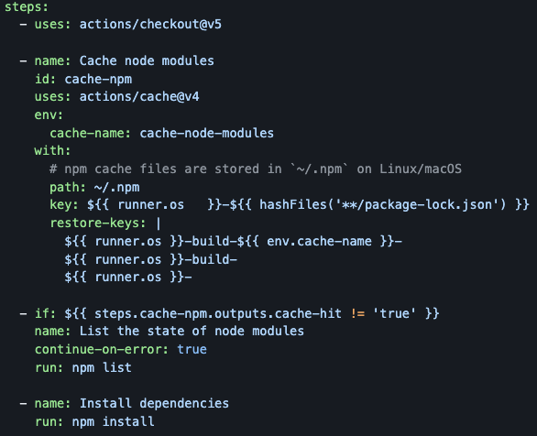

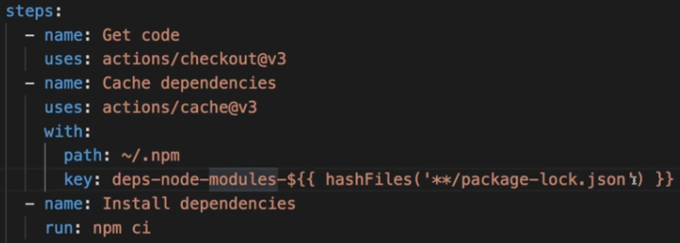

We need to add this cache directive to wherever we install dependencies, like here in build

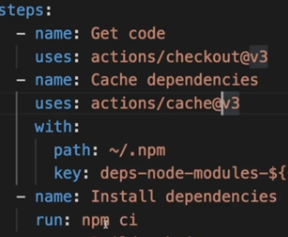

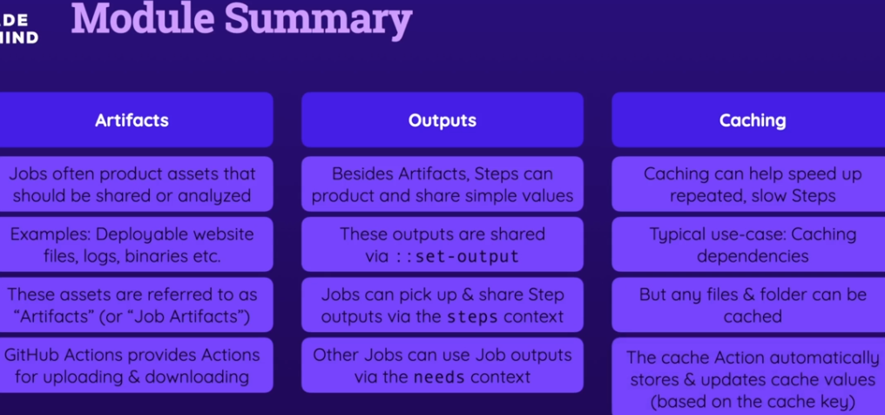

6 Env Variables & Secrets

<https://github.com/qaiser110/ghActions_lint_test/actions>

So the web server port is dynamic. I set it here with this environment variable.

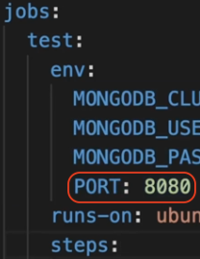

Therefore, this env variable can be used here in this Workflow definition file.



Now the exact syntax can be different if you're using a different shell here. In general, you can also use the Shell key when defining a step to switch from the default operating shell to a different one. For example, instead of using Bash, which is the default on non-Windows platforms, you could switch to Python to execute all your commands as Python commands. So if you are switching to a different shell, add this shell key to your steps, you might need to change the syntax for interpolating env variables, but in that case, the official shell documentation is the place to go.

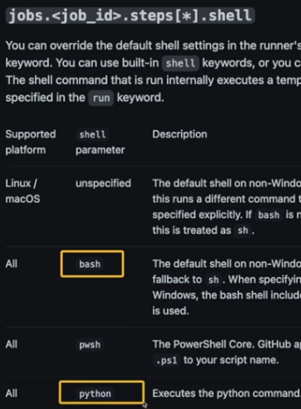

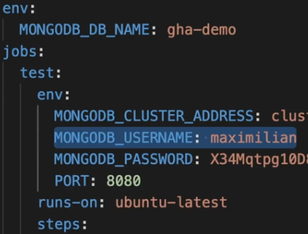

So here on Ubuntu latest in that default shell this is the syntax for interpolating and outputting an environment variable. 

But there also is another way of getting access to an environment variable value in your Workflow definition file.

In deploy, this should be available because it is defined as workflow env variable



but this should not be available because it is defined on test, and not deploy



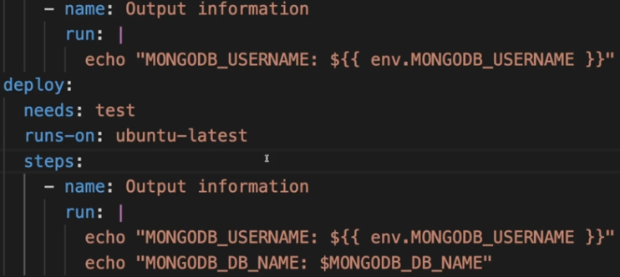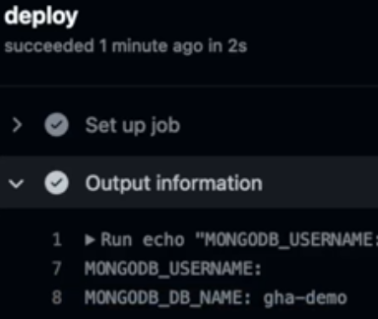

### Secrets

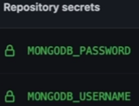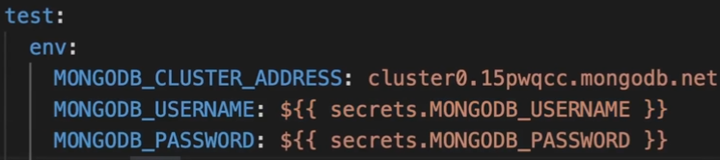

### Environment Secrets

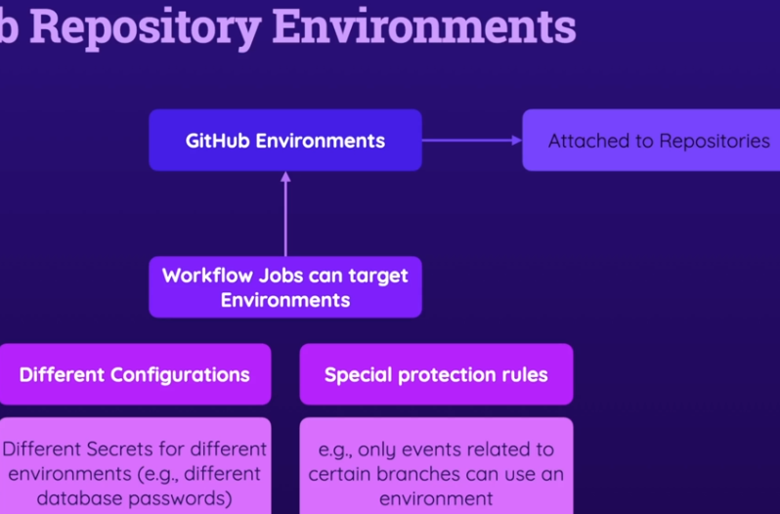

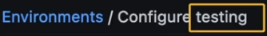

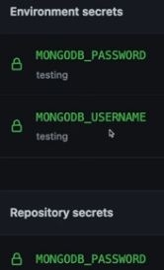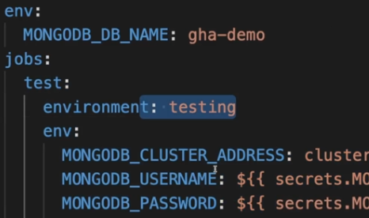

Now, in addition to environment specific secrets, you can do more with environments. For eg, you can require reviewers to make sure that whenever a workflow executes, a reviewer has to approve that workflow before it starts running.

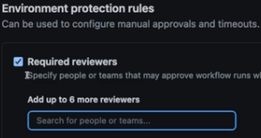

You could also add a wait timer so that every job pauses for 15 minutes before it actually starts. And you can also add some branch protection. And for example, make sure that a job that uses this environment will only be executed if it was triggered based on a branch you selected. For example, here I could add a deployment branch rule and say that only if the main branch was part of the event that triggered the workflow execution, only if that branch was part of the event, jobs that referenced the testing environment should execute.

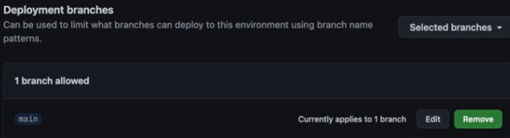

So if I would push to a different branch, to the dev branch, and that would trigger the workflow execution, any jobs referencing the testing environment would not be executed. And in general, this workflow can be triggered if I push to the dev branch.

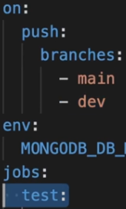

But thanks to this rule, this test job would not execute. And I will save that rule, so I will add this rule and keep this change so that I can also show this to you in action. So with that, I finish my environment configuration. I added that rule and my secrets. I updated the workflow file by adding this environment to the test job. And therefore, now if I create a new commit, add an environment, and I push this, you will see that here where I'm pushing to the main branch this will all execute successfully because it's now using these secrets from that environment and it's passing this protection rule. But if I later try the same by pushing to the dev branch, you will see that it will fail. But first of all, let's wait for this execution to finish here. Here we go. So the secrets were obviously picked up successfully, otherwise this wouldn't have finished successfully. And if I now go back and check out a new branch which I named dev and I now push this dev branch to my remote repository, you will see that the workflow also will be triggered because I have this trigger added to my workflow configuration file. But nonetheless, you see that it actually failed because this first job, this test job wasn't executed because the branch dev is not allowed to deploy to the testing environment due to this protection rule that I added.

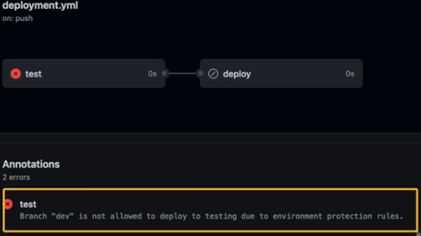

7 Controlling Execution

## Controlling Workflow & Job Execution

<https://github.com/qaiser110/ghActions_lint_test/actions>

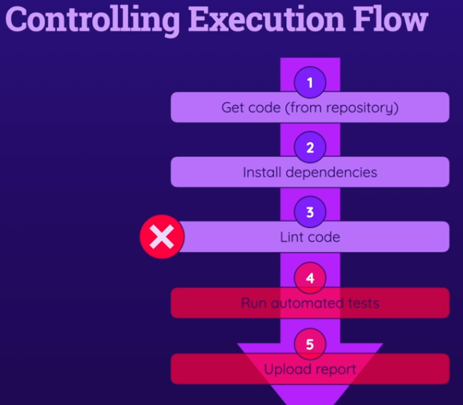

At this point in the course, we're able to write solid GitHub Actions workflows that do a variety of things. But also at this point in the course, we're only able to write workflows that always execute from A to C. So from start to finish and that stop execution if an error occurs. If something goes wrong, if some step fails then the job to which the step belongs is canceled. All subsequent steps after the failing step are not executed and all other jobs are not executed. If one job fails because of a failing step. That's the default behavior and often that behavior makes a lot of sense. But sometimes you want to continue executing steps even if one step failed and some steps should even only be executed if another step failed. And it's not just about failing steps. In general we typically want more control over when exactly which job and step executes, because it's not the case that you always want to execute all jobs and all steps. Instead, often you have some conditions. And therefore discourse section is about controlling execution flow. It's about controlling when a job executes and when the steps in a job execute. You will therefore learn how to run your jobs and steps conditionally, and which tools GitHub Actions gives you to control that. And we'll then also dive into other execution flow related topics, like for example using an execution matrix or a job matrix, and you will learn what that is and when you might want to use that feature. And we'll explore the concept of reusable workflows, which can save us some time and some extra writing.

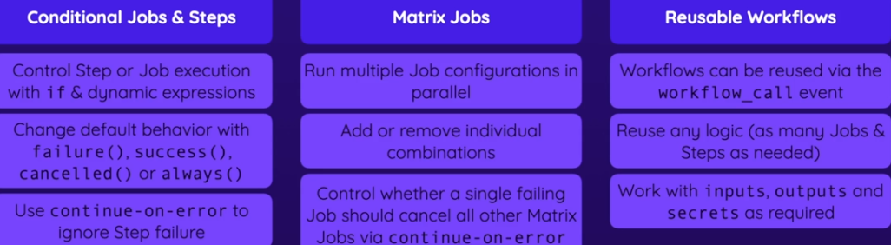

### Understanding Conditional Steps & Jobs

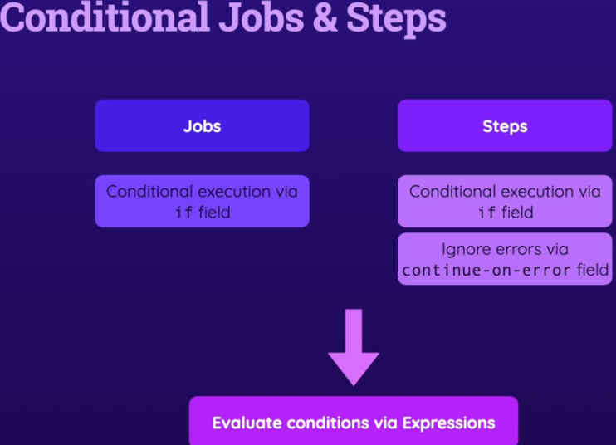

This is the workflow that we have in pur project:

Controlling-Execution/.github/workflows/execution-flow.yml

name: Website Deployment

on:

push:

branches:

- main

jobs:

lint:

runs-on: ubuntu-latest

steps:

- name: Get code

uses: actions/checkout@v3

- name: Cache dependencies

id: cache

uses: actions/cache@v3

with:

path: ~/.npm

key: deps-node-modules-${{ hashFiles('**/package-lock.json') }}

- name: Install dependencies

run: npm ci

- name: Lint code

run: npm run lint

**test**:

runs-on: ubuntu-latest

steps:

- name: Get code

uses: actions/checkout@v3

- name: Cache dependencies

id: cache

uses: actions/cache@v3

with:

path: ~/.npm

key: deps-node-modules-${{ hashFiles('**/package-lock.json') }}

- name: Install dependencies

run: npm ci

- name: Test code

run: npm run test

- name: Upload test report

uses: **actions/upload-artifact@v3**

with:

name: test-report

path: **test.json**

**build**:

needs: test

runs-on: ubuntu-latest

steps:

- name: Get code

uses: actions/checkout@v3

- name: Cache dependencies

id: cache

uses: actions/cache@v3

with:

path: ~/.npm

key: deps-node-modules-${{ hashFiles('**/package-lock.json') }}

- name: Install dependencies

run: npm ci

- name: Build website

id: build-website

run: npm run build

- name: Upload artifacts

uses: actions/upload-artifact@v3

with:

name: dist-files

path: dist

**deploy**:

needs: build

runs-on: ubuntu-latest

steps:

- name: Get build artifacts

uses: actions/download-artifact@v3

with:

name: dist-files

- name: Output contents

run: ls

- name: Deploy

run: echo "Deploying..."

One quick note regarding the test job. I'm uploading the test report. test script just produces a report in this project because of the configuration I provide here in this vite.config file, this test.json file is generated to be precise, and it's this test.json file that's uploaded using upload artifact action,

| - name: Test code  run: **npm run test**  - name: Upload test report  uses: actions/upload-artifact@v3  with:  name: test-report  path: **test.json** | 07-Controlling-Execution/vite.config.js  export default defineConfig({  plugins: [react()],  test: {  ...  reporters: ['json'],  outputFile: **'test.json'**  }, |
| --- | --- |

Let's say we want to upload the test report only if some **tests** fail. So it makes sense we could add an **if** condition here, that ensures that this step only runs if this test step fails. But the default behavior of GitHub Actions is, if this **test** step fails, this next step normally wouldn't even be executed, the entire job to which the step belongs is aborted.

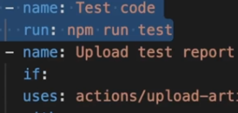

So what do we do to make this **Upload test report** run if the **test** step fails. And by default if **test** step succeeds, **Upload** step will run, but we don't want it to run in case **tests** pass, if we would add a condition that makes sure that this step only runs of that step failed, we would make sure that it does not run if that steps succeeds, so if our tests succeed but on the other hand, it does still run if our tests fail, which currently is not the case.

Now, therefore, we need a way of referencing this step. We must find out whether that step failed or succeeded, and to do that we can add the id field to that step. Now, we did see the id field in action a little bit earlier in the course already. You can add the id field to any step you have and that allows you to assign a unique id to every step which then can be used to reference that step and use data from that step in other steps or in your job. For example, we used it earlier in the course to get hold of some outputs that were set in a step. Here I'll give this step an id of run-tests but the id name is totally up to you.

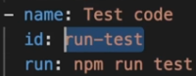

It doesn't have to be run-tests. And here in the if condition, we can then reach out to the special steps context object, which is one of the context objects supported by GitHub. Here it's this one. That's the **steps** context object, which we're using now.



And on this steps object, we can reach out to other steps by their IDs, so now here I add run-tests to reach out to this specific step.

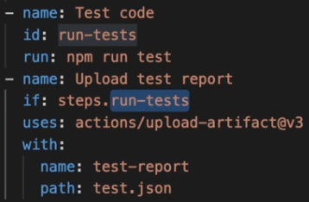

And then we learn in the official documentation that on this steps context object, when we do reach out to a specific step by its id, we actually can get information about the outputs produced by that step, which is what we did earlier in the course already but we can also get the conclusion or the outcome of that step.

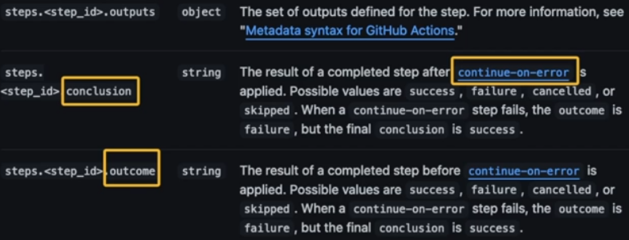

And in the end, these two fields simply tell us whether the step succeeded or failed. Now, we've got two fields here, conclusion and outcome, instead of just one field because we also have this continue-on-error field, which we'll explore later, which actually allows us to continue after a step even if it failed and in that case, we've got one field that tells us whether the step would have failed without continue-on-error but then actually was treated as a success because of that field added but since we don't know that field right now, we can ignore it and we can simply use the outcome here.

So here we can use steps.run-tests.outcome to find out whether that step succeeded or failed.

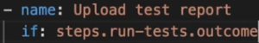

And in the end, both outcome and conclusion then contains some text that tells us whether the step succeeded and we get, for example, success as a text if it succeeded, failure if it well, failed, canceled if it was manually canceled or skipped if it was skipped maybe due to some other if condition that was attached to that step.

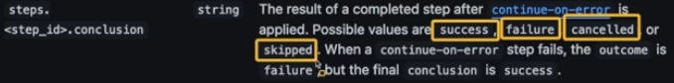

So in our case here, we're looking for the failure text because we know that if this step failed, this run-tests step failed, then we wanna upload our test reports. So here we check if the outcome is equal to failure. And failure is wrapped between single quotes because that is some text.

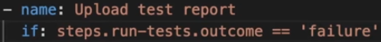

With this condition, what we expect to see is that the **Upload** step runs on **Test** step **failure** but not on **Test** step **success**. But if we push a new commit, our test step fails as expected, but we still skip the **Upload** step. The reason is that yes, our condition does check whether its step **failure**, but GitHub Actions still ignores this step because it still has its default behavior of not executing any other steps after a failing step.

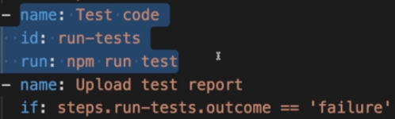

To change that default behavior, we must add a special function **failure()** to this **if** condition of this step.



### Special Conditional Functions

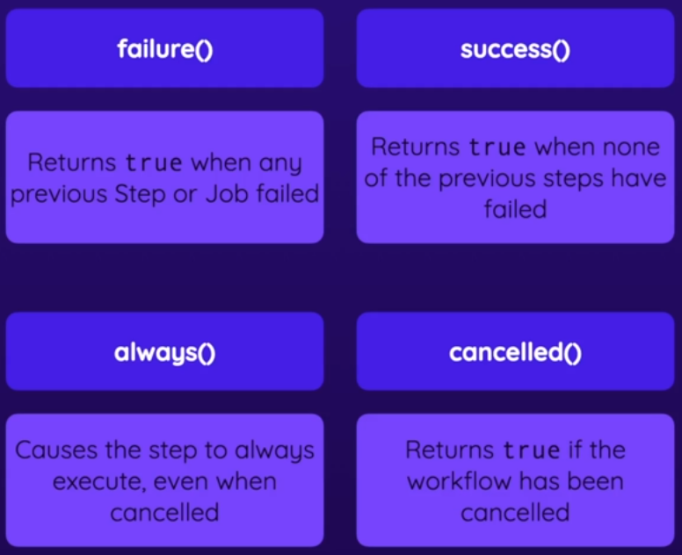

Now by adding failure() to our if condition, we make sure that GitHub actions realizes that this step should still be evaluated if we have failing steps or jobs before that step. And we still need this second condition so that, if for some reason suppose installing the dependencies fails, this failure() would still return true but this condition would not return true because this **run-test** step wouldn't have failed



### Conditional Jobs

So now we got started with that if field on a step to ensure that a step runs even if a previous step failed. Now the if field is also available on job level so that we can add it to jobs instead of just steps. And to show this at a concrete example, let's say we have a new job here, which I'll name report which will run on ubuntu-latest. And where I have a step called output information where I simply run some echo command here where I say "something went wrong." And then let's say we actually output something across multiple lines and we then output the GitHub context object like this. So this is now a new step in a new job and my goal is to run this job only if some other job failed.

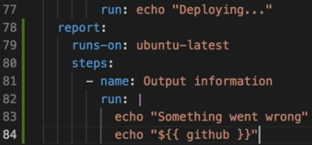

Now, if that's the goal, we can add a if check here and use this special failure function to make sure that this job will run if any other job failed because failure will return true here if any other job failed, and only then this job will be executed.

So now with that added, we can create a new commit "added conditional job" and then push this to the repository. Now there, this workflow of course is now triggered and what you'll notice is that now report here is actually skipped. This I can hear signals that it was skipped. Now it was skipped because the way we configured it actually runs this job in parallel to all the other jobs. That's why it's also shown visually below the other jobs. It runs in parallel. That means that it's started right at the beginning of the workflow run. And there of course, no other job has failed yet. So GitHub is not waiting with this report job until all other jobs have succeeded or failed. Instead, it will execute report right away. And there, this failure condition simply is not met. So this alone won't do the trick.

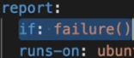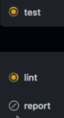

Instead of our goal is to run this job only if any other job failed, we must add the needs key here and then need both the lint job. So this first job here as well as the deploy job which is the last job in line after build and test. So now we add these two jobs as prerequisites for the report job and therefore GitHub Actions will delay the execution of the report job until these other jobs have finished.

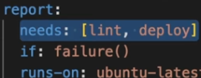

### 008 More if Examples

So we have this Cache step, it's caching this global **~/.npm** cache folder, and so this **npm ci** step is faster because it will use this internally managed npm cache. It would be even faster though if it would cache the entire **node_modules** folder which is the local folder with all the project dependencies installed. And we wouldn't even have to run the **npm ci** step if we restored that folder.

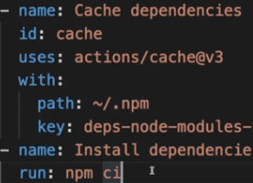

The cache package has this **cache-hit** output that we can use.

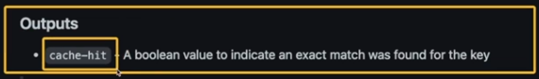

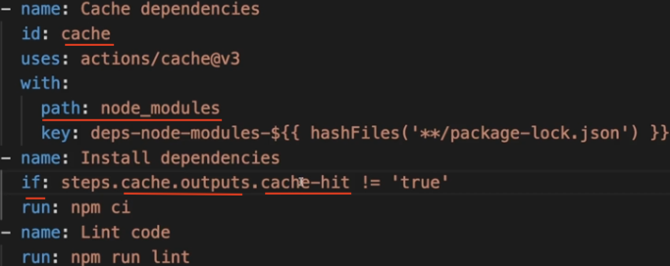

### Ignoring Errors & Failures with continue-on-error

If we set **continue-on-error** to **true**, the next step & job will run even if there is a failure in a step.

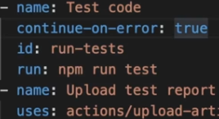

That's where this conclusion and outcome value becomes important. The conclusion field simply tells us whether the job is treated as a success after continue-on-error was evaluated. And typically that will be success because continue-on-error has the goal of treating the step as a success even if it failed. Now it could still fail for technical reasons if the runner somehow crashes and you could still manually cancel the job, and it could also be skipped if there was some if condition attached to the step, if that caused the step to not even be started but in most cases you will get success here.

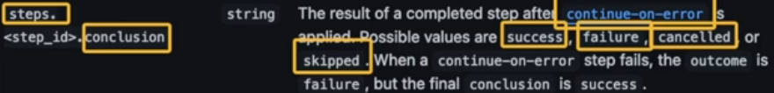

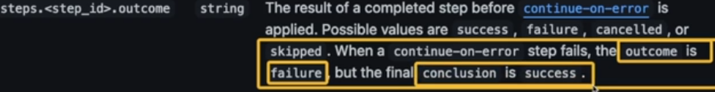

### Matrix Strategies

We have this simple workflow

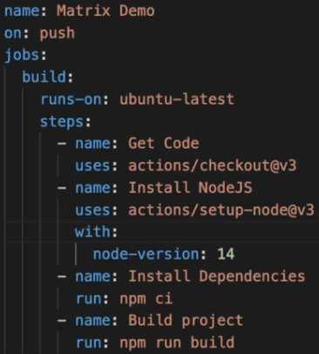

The idea behind a matrix is that you can run the same job with different configurations. For eg, if you wanna run this build job with different configurations, on different runners, or different node versions or any other values you might be interested in changing at the same time.

You do that by adding the strategy field to your job, so directly to the job to which it should apply. And then the matrix below it. And then here under matrix, you can add any keys of your choice, for example, node-version, but this is totally up to you. It can be any value that could be changing and for which you wanna run the job for different values.

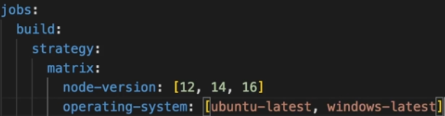

And then you can specify those configs as dynamic values for those matrix variations you wanna run

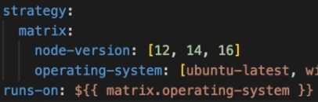

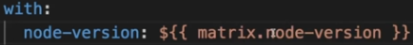

So this will run on **ubuntu-latest** with **node-version** 12, 14, 16

And also run on **windows-latest** with **node-version** 12, 14, 16

And if you run this, you'll see 6 jobs running in parallel

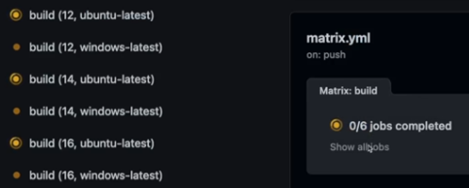

When using this matrix strategy, if one job fails, the other jobs are canceled and skipped.

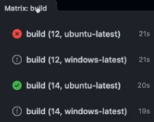

If you don't want that behavior, you can use **continue-on-error** on the **job** level, and set this to **true**.

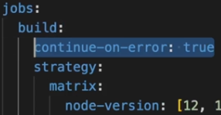

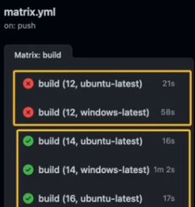

If you added **node-version** 18 here, then the job will run on **node-version** 18 for both **ubuntu-latest** & **windows-latest**

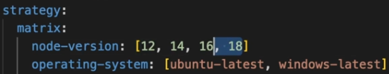

Let's say you want to run on **node-version** 18 only for **ubuntu-latest** and not on **windows-latest**

You can do this with **include** or **exclude** option

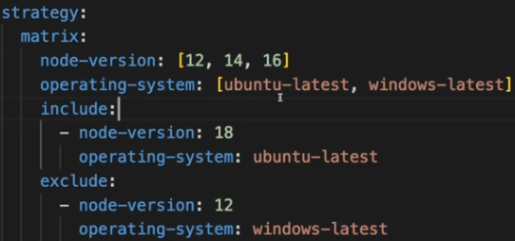

### 012 Saving Time & Code with Reusable Workflows

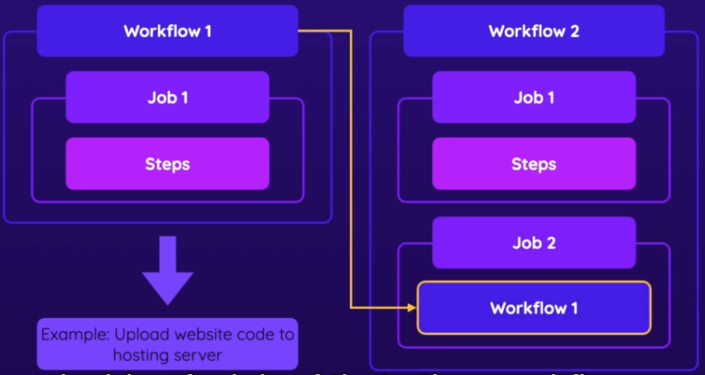

We set on: workflow_call on workflows we want to call from other workflows

07-Controlling-Execution/.github/workflows/**reusable.yml**

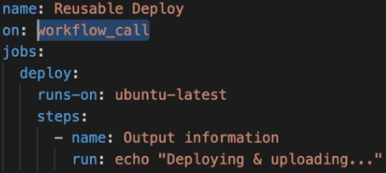

And in our main workflow, we'll replace the whole body with uses directive

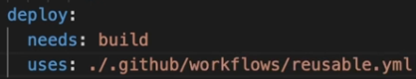

#### Send inputs to reusable workflows

If we needed some inputs to the reusable workflow, we can use inputs.



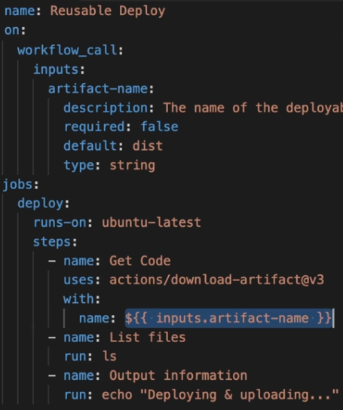

And we send the input from parent workflow:

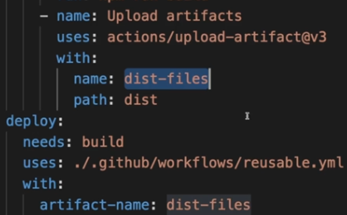

#### Send secrets to reusable workflows

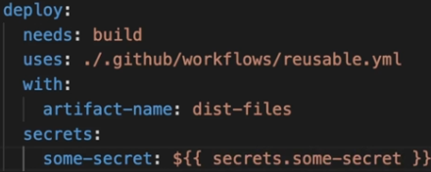

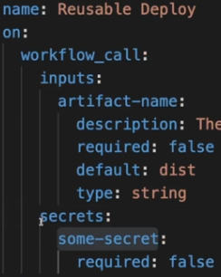

### Output from reusable workflows

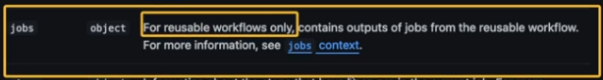

#### Step Output

You might be returning an output from a step in your reusable workflow like this:

- name: Set result Output

id: set-result

run: echo "step-result=success" >> $GITHUB_OUTPUT

#### Deploy Job Output

jobs:

deploy:

outputs:

outcome: ${{ steps.set-result.outputs.step-result }}

#### workflow output

outputs:

result:

description: "Outcome of the deploy step"

value: ${{ jobs.deploy.outputs.outcome }}

#### Complete reusable workflow

name: Reusable Deploy

on:

workflow_call:

inputs:

artifact-name:

description: "Artifact to download"

default: "dist"

required: false

type: string

**outputs**:

**result**:

description: "Outcome of the deploy step"

value: ${{ jobs.deploy.outputs.outcome }}

jobs:

deploy:

outputs:

outcome: ${{ steps.set-result.outputs.step-result }}

runs-on: ubuntu-latest

steps:

- name: Get build artifacts

uses: actions/download-artifact@v3

with:

name: dist-files

- name: List files

run: ls

- name: Deploy

run: echo "Deploying..."

- name: Set result Output

id: set-result

run: echo "step-result=success" >> $GITHUB_OUTPUT

Main Workflow

deploy:

uses: ./.github/workflows/reusable.yml

with:

artifact-name: "dist-files"

print-deploy-result:

needs: deploy

runs-on: ubuntu-latest

steps:

- name: Print deployment result

run: |

echo "Deployment result: ${{ needs.deploy.**outputs**.**result** }}"

8 Jobs & Docker Containers

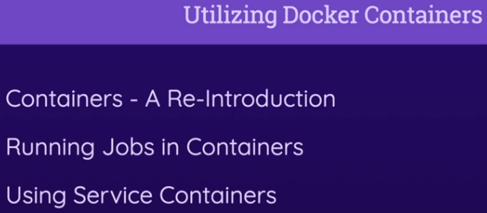

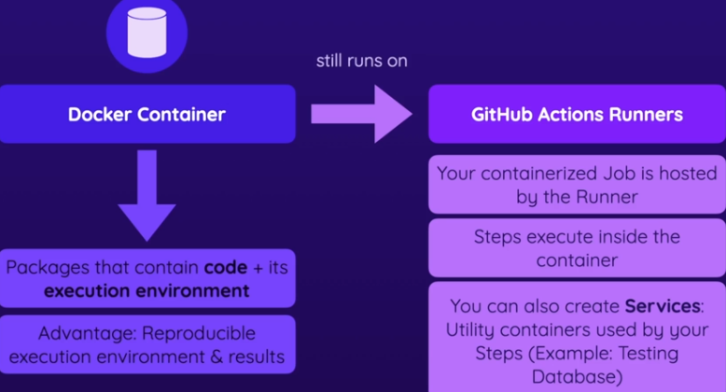

### Connect Mongo DB

#### Allow access from anywhere

Go to MongoDB > **[IP Access List](https://cloud.mongodb.com/v2/68f644d7ca30fe58cf95ff78#/security/network/accessList)**

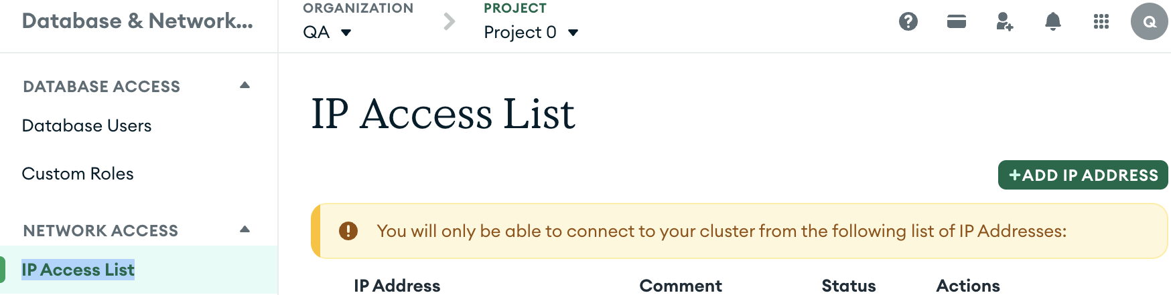

Click 

Click 



#### Set password

Go to **Database Users**, and Edit the user to set password

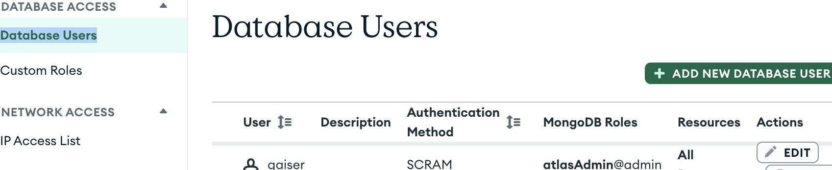

#### Get the connection string

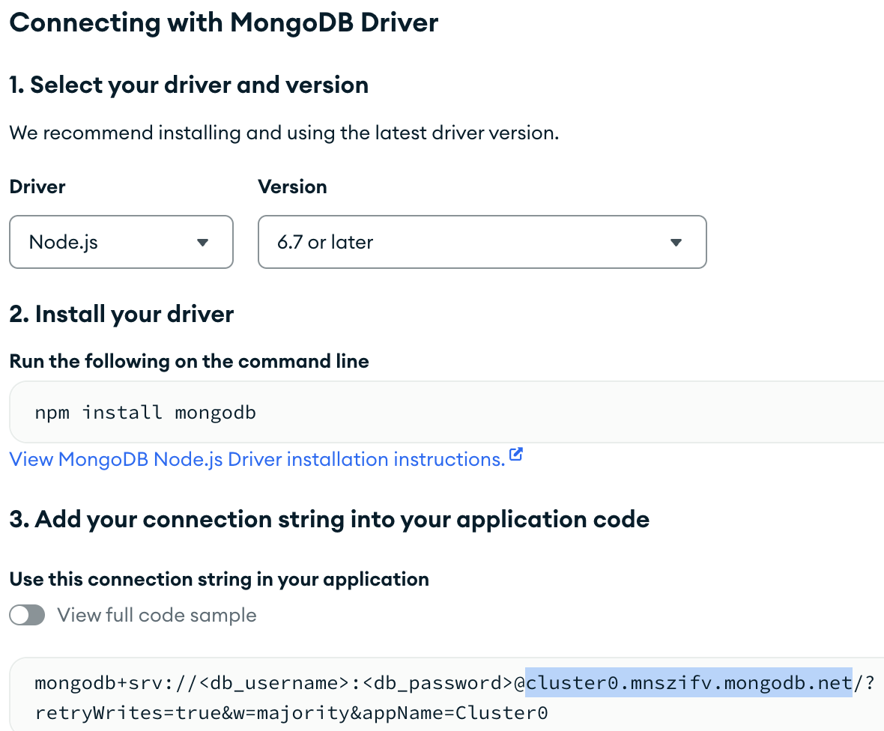

#### Set the configs in the workflow yml file

env:

MONGODB_CONNECTION_PROTOCOL: mongodb+srv

MONGODB_CLUSTER_ADDRESS: cluster0.mnszifv.mongodb.net

MONGODB_USERNAME: ${{ secrets.MONGODB_USERNAME }}

MONGODB_PASSWORD: ${{ secrets.MONGODB_PASSWORD }}

#### Set Repository secrets accordingly

<https://github.com/qaiser110/ghActions_Docker_Containers/settings/secrets/actions>

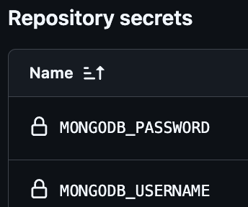

### Why would you Use Containers (With GitHub Actions)

You can create Docker Containers by writing a Docker file that defines how your Container, so how this package is set up. And you always start by defining a base image. Then, some env variables you need for this container. And then some steps that are always executed when this Container is prepared and which give me an environment in which I can run this application whenever I want to on whichever machine I want to as long as that machine supports Docker.

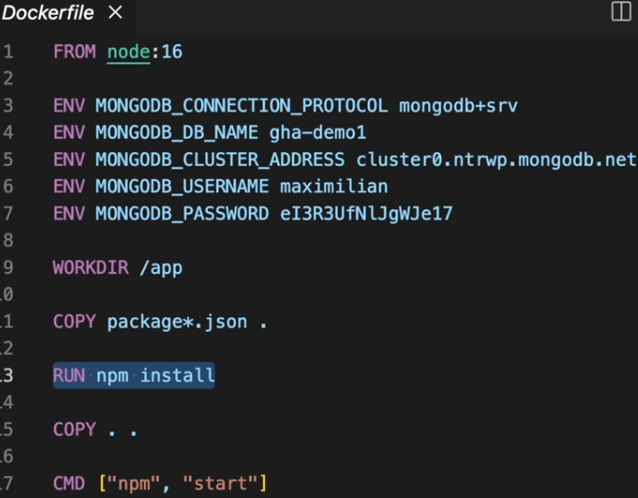

With GitHub Actions you can run your jobs and their steps on "Just the Runner" machine, which you define. That's what we did thus far, but you can also run them inside of a Container defined by you. The advantage of using Containers instead of the Runner is that with a Container, since you defined the entire environment you have full control over the environment over the installed software and the setup steps that were performed for setting up that environment. If you are running your jobs and their steps directly on the Runner, then you are stuck with that Runner. And that, for example, means that you have an environment with a predefined operating system version and a predefined list of software. I did show you this information about the pre-installed software earlier, and it depends on which runner you are using. And depending on that choice, you then have various tools and services pre-installed and running on that runner machine provided by GitHub. Now, often that maybe all the software you need but sometimes some software or setting might be missing or you might have a version that you don't wanna work with. Now of course, you can always go to a Workflow and add a new step where you install some extra software. That's always an option, but when using Containers you could create such a predefined environment separately from your GitHub Actions Workflow definition file and you could reuse the container in different workflows wherever you need that environment. So that could be the advantage of using such a Container that you can build your own clearly defined environment in which your code will run or will be built or tested or whatever you want to do with it. Now as mentioned, GitHub Actions supports Docker Containers and you can simply run Docker Containers on top of those Runners provided by GitHub and by GitHub Actions. Your containerized job is then simply hosted by the Runner so it's running on that Runner machine but in an isolated environment. The environment defined by you in the Container definition and the steps, and that's the important part the steps of the job are then executed inside the Container. And they're also is another feature called Services or Service containers, which we will also explore later in this section, which allows you to run extra services in Containers that might be needed by your main build job

### Run Jobs In Containers

Right now we're running this test job directly on this Ubuntu machine provided by GitHubActions. There's nothing wrong with that, and in many cases there's absolutely no reason to use containers. But it make sense to use containers if you want full control over the environment. For eg, on my own website, I have a testing job, I'm using this playwright tool to run integration tests. It opens different browsers and tests the website in different browsers. And here I'm using a base image provided by the team behind this playwright testing tool that actually comes with all these browsers pre-installed.

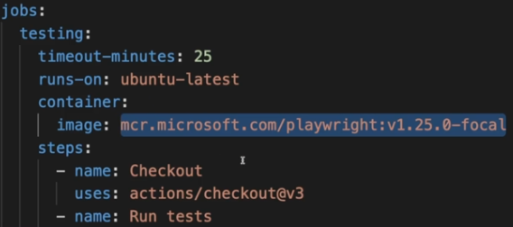

With that I don't have to add an extra step in my workflow to install these browsers manually. I could do this, but it would take some extra time for which I'm paying, since I'm paying for execution time here in my private repository. And besides paying for that time it also simply wastes some time if I can just use this predefined environment that has all these browsers installed, and where I therefore don't have to go through these installation steps manually.

So that's one example where I actually put one job, the testing job, in this real workflow into a container. A container that's based on some image that comes with a certain environment, which I want to use here, an environment that has certain browsers pre-installed. Now here, back to our simpler example in this course, we technically don't need an image we could just run all these steps on just the runner machine, it would work just fine but we can also put all these steps into a container by using some base image, so some base environment, simply to see how that would work. And that's exactly what we're going to do here. And to put a job and its steps into a container all you have to do is you have to add the container key here to your job definition in your workflow definition file. So nested below your job identifier, you put the keyword container. And then as a value for this container you can specify the name of the image which you want to use. For example, node. Now, when it comes to these image names you can use you have to use names of images that are available on public repositories. Like for example, Docker Hub, which is the official docker image repository. You could publish your own images on Docker Hub as well but you also find many official images there. For example, a base image that comes with just Ubuntu installed, but also an image for the Postgres database if you needed an environment that comes with that database pre-installed. And amongst all these other images you for example, also find a node image here which gives you an environment that comes with Node.js pre-installed. And if you then click on such an image here on Docker Hub you learn more about it and about the different versions of the image are available and how they differentiate from each other, and what's included in this image. And now here I could use node, which is one possible identifier I can use or node:16, which is a different identifier I can use which gives me a image based on Node Version 16. And I can run all my steps of this job in a container that's based on this image because all docker containers are based on some image.

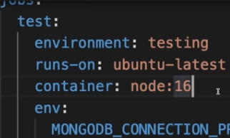

As an alternative to this way of defining the container image, we can also add a nested image key and define our image like this. This syntax is important if you also have further information you want to pass into your container. For example, some environment variable values that might be needed by this image. And that's important, environment variable values that are needed by the image itself, not by your steps, that will then later run in the image. Those env variables which are needed by your steps stay in the env configuration which stays on the same level as container. This nested env field for the container is just about env variables that are directly needed by the image, and if an image would need such variables it would be mentioned in the official image documentation or if you're using your own image, which as mentioned before, could also be published to Docker Hub so that you can use it, then you would of course know which env variables that image might need.

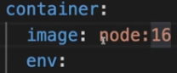

Here for this node image, no env variables are needed, so I won't specify here. But now, all these steps in the test job will run inside of the container based on this image, inside an environment that comes with Node Version 16 installed. Now our Ubuntu machine will just host the image, but the steps running on the image won't have direct access to the machine. You can still use GitHub Actions like the checkout or cache action though, that all still works. GitHub Actions make sure that all these steps still work as before even though they're now running in a container technically.

### Service Containers

So, we saw above how you can put a Job, and its Steps, into a container, which can be useful, if you need full control over the environment. Now, you can also use containers in conjunction with GitHub Actions, to spin up so-called service containers.Say you have automated tests, which might be running as part of our Workflow, but might use a testing database, and that's where service containers come in, because you may runs some extra testing database server. You could add an extra MongoDB cluster, that's only used by your automated tests, or by your development environment. It could be nice to run that testing database server inside of a container/environment that has everything needed by the database only whilst, your tests are running. And which is then shut down, once your tests are finished. And that's exactly what these GitHub Actions service containers are all about. They allow you to run extra services side-by-side. And you could, for example, run a database in a container, whilst, your jobs are running so that your Steps and your Jobs can access that database. And as soon as your Workflow finishes, those service containers will also be shut down. Service containers for running testing databases is just one example. You could use this feature for any service, that's needed by your Jobs, though.

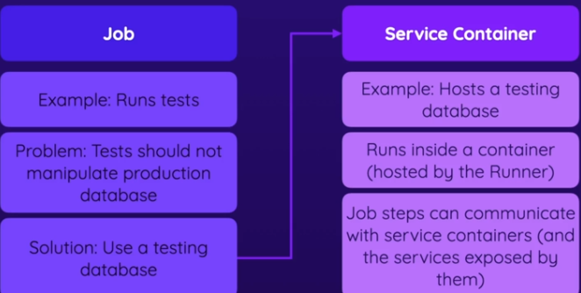

You can use service containers with the jobs that are themselves running in containers, but you can also use service containers in conjunction with jobs that run directly on the runner machine. So here for eg, I do have a job running in a node:16 container but that is technically not needed.

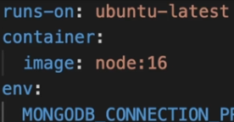

So, you can add a service to this job by adding an extra **services** key. And that's important, **services**, plural, not service because you can add more than one service container for a job. So here I added services for this test job. And then nested below services, you add an identifier, a label for your service. And I could add another-service here, but I only need one service. Now, it's important to note that Services belong to a job, so to one specific job.

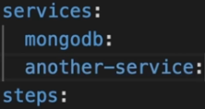

So I named my service mongodb but that service needs more configuration, the image we want to add, DB user/pwd

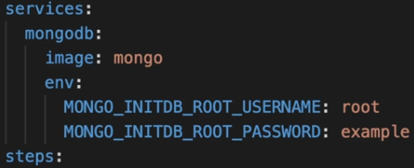

You can see the docs here <https://hub.docker.com/_/mongo>

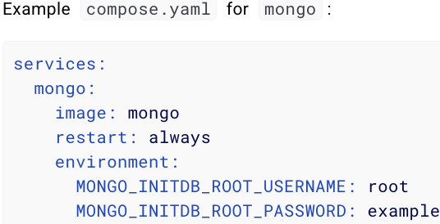

The password doesn't have to be too complex because this is only a testing DB that's running as long as our workflow is running. It will be destroyed after the workflow is finished. So exposing these credentials here is no problem. Now, this also must be the credentials that are used for connecting thereafter and therefore, you should also use the same credentials here for the env variables that are used by the tests in the steps.

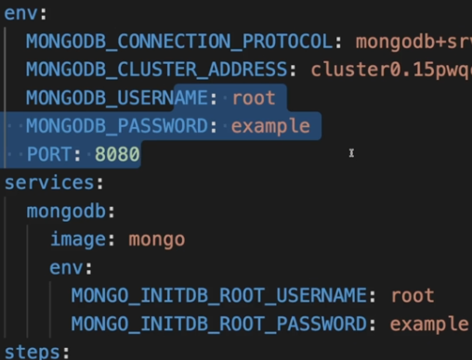

### Communication between Jobs & Service Containers

For the environment (hence the jobs/steps) to communicate with the service container we added, we need to change the mongodb address since we're not using the hosted version now. Now if the job itself is running inside a container

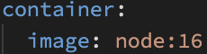

making a connection is super simple because GitHub Actions will automatically create a networking environment, where the label of your service container (in our case mongodb) can be used as the connection address. like this.

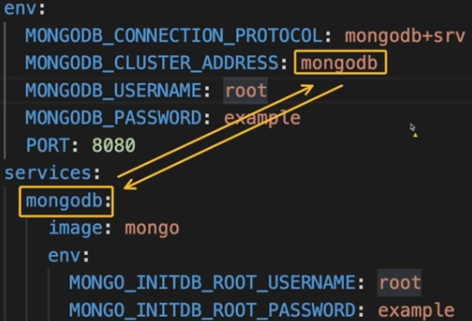

I also must change the connection protocol here. You learn more about how to connect to it here, in [the official docs](https://hub.docker.com/_/mongo).

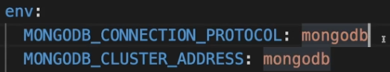

With that cluster address being equal to that label name, we can run this Workflow, without needing any external MongoDB clusters at all. It now works totally isolated, with help of that service container.

But using the label name only works if your job itself runs in a docker container. Things change slightly if our Job is not running in a container. So if I removed this, or commented this out.

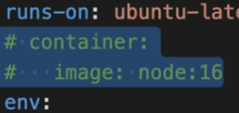

Now the Job will run on the runner itself, and not inside of this container anymore. You can still use service containers, and you still set them up as before, here. But now there won't be a network where you can use these service container label for connecting. That won't work anymore. Instead, now you have to use this localhost IP address, 127.0.0.1. And if there are any specific ports that are needed, you also must add that port here. In case of MongoDB, the default port used is this port 27017, so I'll connect to that port here. And even more importantly, I have to open that port here, on my service container. That's done by adding the extra ports setting. And then here the internal port 27017 should be forwarded to port 27017 on the runner machine.

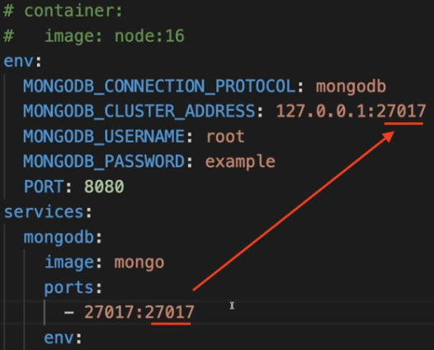

9 Custom Actions

### Why build custom actions?

[https://docs.github.com/en/actions/concepts/workflows-and-actions/**custom-actions**](https://docs.github.com/en/actions/concepts/workflows-and-actions/custom-actions)

[https://docs.github.com/en/actions/reference/workflows-and-actions/**workflow-syntax**](https://docs.github.com/en/actions/reference/workflows-and-actions/workflow-syntax)

So, why would you build custom actions? Well, there are two main reasons. The first reason is that you might want to simplify various steps you have in your workflows. For example, instead of writing multiple, possibly very complex, step definitions, you could build and use a single custom action to simplify your workflow. You could also reuse that action across multiple jobs if you had multiple jobs that performed the same steps,

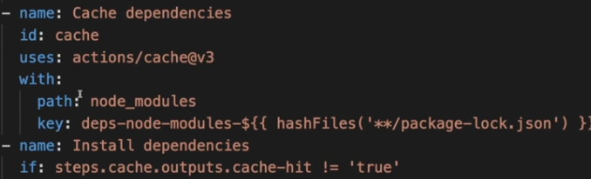

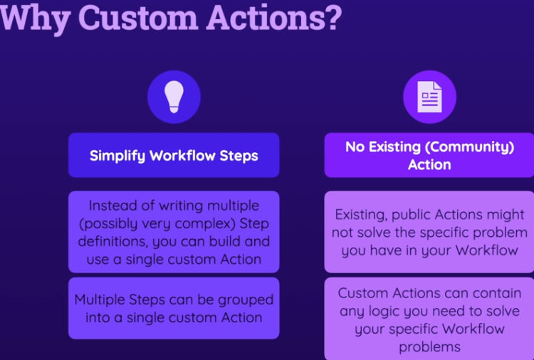

### Custom Actions Types

There are three types of custom actions, and we'll learn how these three approaches work, but the result will always be the same. So the result will always be an action that you use just like you're using any public action.

#### JavaScript Actions

Actions where you write the logic of the action in JS, so you define code in a JS file and that file will be executed whenever your action runs. And in this action code, you can use the NodeJS runtime with all its features and any packages of your choice to write any JS application that should be executed whenever your action runs.

#### Docker Actions

A Docker action is basically a containerized action, so an application that you put into a container just as you could put jobs or services into containers earlier, and you build such a Docker action by defining a Dockerfile which simply configures how the image for this action container will be built and configured and then that Dockerfile will be used by GitHub to build a container based on the image defined by your Dockerfile and you can then perform any task of your choice with any programming language of your choice in that container since it is your container. You can use any base image, set up any environment and any programming language you want to use. So you have lots of flexibility

#### Composite Actions

The idea behind composite actions is that you don't write any code with any programming language but instead you combine multiple Workflow steps as you could have written them directly in the Workflow file itself as well in one single action. So you combine multiple **run** or **uses** commands or actions in a single composite action and that composite action can then be used in a Workflow. And therefore, composite actions are great for grouping and combining multiple steps that might be reused across jobs or workflows. And the great thing about composite actions is that no extra knowledge or skillset is needed because you won't write any code in any programming language. Instead, you're just going to define some steps as you already did it throughout this course.

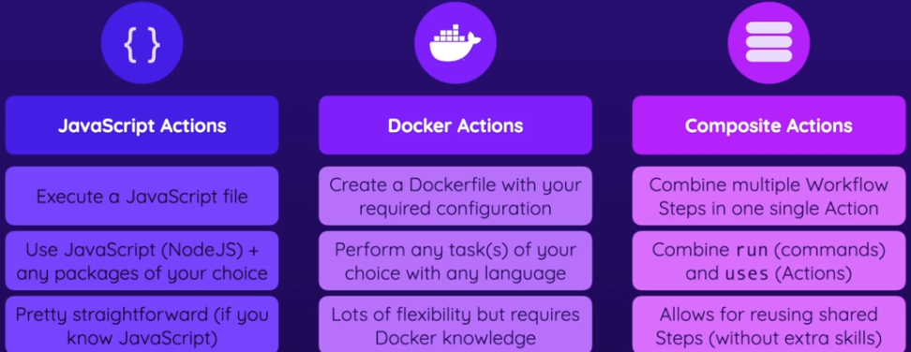

## Composite Action

If you wanna create actions that are available to different workflows in different repositories, you must create them as standalone repositories. But here I'll create a locally available action instead. My goal is to outsource the step for caching the dependencies and for installing the dependencies into a separate action.

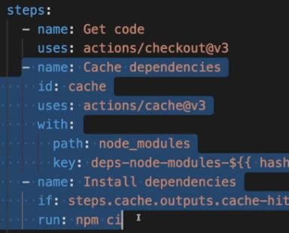

So I'll create a cached-deps folder and move the cached dependencies steps. I won't move the **checkout** step because since my action will only be part of that repository here, I must get the code of the repository before I will be able to use my locally defined action. If my action would be defined as a standalone public repository, then I could move the checkout code into that separate action because I could then reference the action via the repository URL. But since the definition for my action will be part of this project, the **checkout** code can't be part of the action itself because we must check out the project code before we can use the action defined in the project code, and in the project files.

And for all three types of actions, composite or JavaScript or Docker action, you always must add an action.yml file. So a file that contains the configuration and definition of that action. This file must be part of any action you create. It also must be part of any repository that holds an action you might create.

So here in this file, we now configure this action. And for this composite action, this action.yml is the only file we need. We specify a **name** but now we don't need an **on** key for custom actions. Actions don't need a trigger because they are not workflows, instead they are used as part of workflows. We add the **runs** key. But no **steps** key. And **runs** then needs a nested key called **using**, which must be set to **composite** here. Up to this point, you have no choices regarding that. And this will tell GitHub Actions that this is a **custom composite** action. Then, we add the **steps** key, and the steps to execute.

.github/actions/cached-deps/action.ym

name: 'Get & Cache Dependencies'

description: 'Get the dependencies (via npm) and cache them.'

**runs**:

using: 'composite'

**steps**:

- name: Cache dependencies

id: cache

uses: actions/cache@v3

with:

path: node_modules

key: deps-node-modules-${{ hashFiles('**/package-lock.json') }}

- name: Install dependencies

if: steps.cache.outputs.cache-hit != 'true'

run: npm ci

shell: bash

l

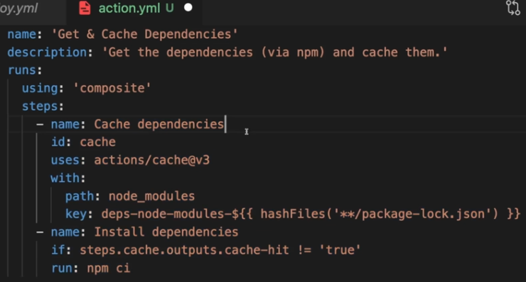

Now, if you're using the **run** key in a custom action, then you must add a **shell** key and choose which shell to use for executing the step. And here I wanna use **bash** as a shell. So that's an extra setting you must add.

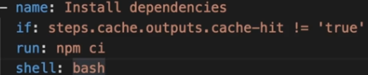

And with that, we built our first action. Now we can use that action in our workflow.

### Using Custom Actions In Workflows

Now, how do we use actions and workflows? Well, for that I'll go to my workflow file, and now here in that lint job, I wanna replace these two steps with my custom action. To do this, I'll give it a name, load and cache dependencies, for example. And then we use the uses key, just as we used it for actions before as well, there is no difference regarding that if you're using your own custom actions, you still use the uses key. Now, the value you define here simply depends on where your custom action is stored. If you did create your action as a standalone GitHub Repository, you would simply add your Repository Identifier here. For example, Maxacademind1/my-action, if my GitHub Repository name would be my action and this would be my account name. That's how I could refer to my own action stored in my own GitHub Repository.

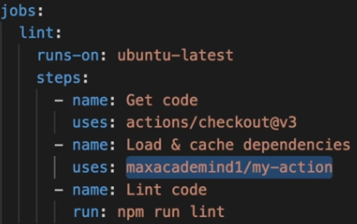

Here I have a local action though, stored locally in this project, and therefore what you pass as a value to uses instead is a path to this action folder. For that you start with **./** to construct a path relative from the root project folder and then we dive into the GitHub folder and then into /actions in my case since I named this folder, actions, and then cached-deps is my other folder name.

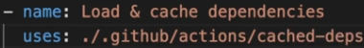

And now we can add this custom action in all places

.github/workflows/deploy.yml

jobs:

lint:

runs-on: ubuntu-latest

steps:

- name: Get code

uses: actions/checkout@v3

- name: Load & Cache dependencies

uses: ./.github/actions/cached-deps

- name: Lint code

run: npm run lint

test:

runs-on: ubuntu-latest

steps:

- name: Get code

uses: actions/checkout@v3

- name: Load & Cache dependencies

uses: ./.github/actions/cached-deps

- name: Test code

id: run-tests

run: npm run test

### Adding Inputs to Custom Actions

So, that's our first custom action. Now, sometimes you also want to make your actions configurable by accepting inputs. For eg, we could add an input that allows users to control whether dependencies should always be installed even if they were cached before. So I'll add an input called **caching**. If I set **required** to **true**, users will have to provide a value when using this action. If they don't, the action will fail. So maybe I'll set it **required** to **false**, so now, it's actually not needed. If you set **required** to **false**, you must make sure that your action code does not fail, if a value is not provided. And you can add a **default** value **true**. We could then use the caching input in our steps, and assume a default value of **true**, unless users specify different value when using this action. And we can use this input by adding the if key to **Cache dependencies** step, and then using the inputs context object to access the inputs received by this action, this **caching** key. And then, check if it's equal to **true**, then this **caching** step will be executed. If it's set to any value but **true**, this step will not execute. Now in **Installing dependencies** step, I already have an **if** check, but now, we need to add another check, to check, if user doesn't wanna use caching, then this step should execute.

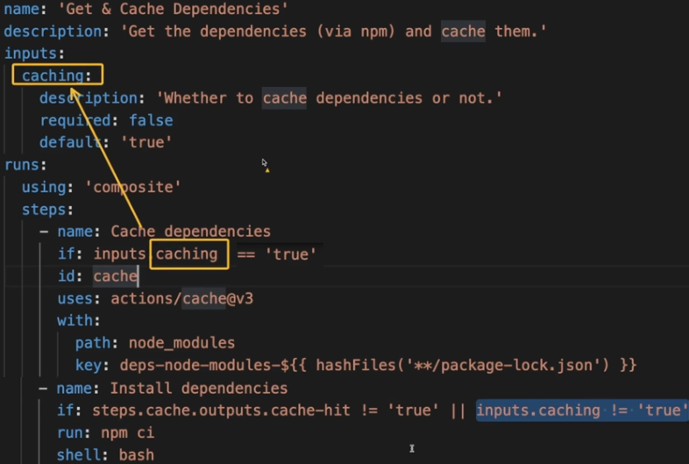

.github/actions/cached-deps/action.yml

name: 'Get & Cache Dependencies'

description: 'Get the dependencies (via npm) and cache them.'

inputs:

**caching**:

description: 'Whether to caching dependencies'

required: false

default: 'true'

runs:

using: 'composite'

steps:

- name: Cache dependencies

if: inputs**.caching** == 'true'

id: cache

uses: actions/cache@v3

with:

path: node_modules

key: deps-node-modules-${{ hashFiles('**/package-lock.json') }}

- name: Install dependencies

if: steps.cache.outputs.cache-hit != 'true' || inputs.**caching** != 'true'

run: npm ci

shell: bash

Now, to provide this input as the action's consumer workflow, you'd use the **with** keyword:

.github/workflows/deploy.yml

- name: Load & Cache dependencies

uses: ./.github/actions/cached-deps

with:

**caching**: 'false'

### Adding Outputs to Custom Actions

Now, just as you can add inputs to your custom actions, you can also add outputs to your custom actions. And to add an output, you add the outputs key on the same level as you added inputs, then nested below it, any output with any identifier of your choice. For example, used dash cache. And then nested below that, a description for this output. Cache was used, for example, or whether the cache was used.

name: 'Get & Cache Dependencies'

description: 'Get the dependencies (via npm) and cache them.'

inputs:

caching:

description: 'Whether to caching dependencies'

required: false

default: 'true'

**outputs**:

used-cache:

description: 'Whether the cache was used'

runs:

To now assign a value to it, you have to add the value key just as we did it earlier in the course when we added an output to one of our jobs. Now, the value here should refer to our steps and therefore here I'm using a dynamic expression, and then the steps context. And now we must refer to one of our steps with help of the IDs assigned to the steps. For example, here I could add an ID to the install dependencies step called install, and use that same ID up here, so that ID which I defined down there.

outputs:

used-cache:

description: 'Whether the cache was used'

value: ${{ steps.install }}

runs:

using: 'composite'

steps:

- name: Cache dependencies

if: inputs.caching == 'true'

id: cache

uses: actions/cache@v3

with:

path: node_modules

key: deps-node-modules-${{ hashFiles('**/package-lock.json') }}

- name: Install dependencies

id: install

And then in that install dependencies step I could run multiple commands where one of the commands installs the dependencies, but the other command uses the set dash output command we learned about earlier in the course. To set an output with the name, let's say cache, this name is up to you though, and set it equal to a value of between single quotes. And now here I want to use another dynamic expression and actually use my input here which I called caching. So here I can then use inputs.caching. Of course therefore, the output is kind of redundant because in the end, I set it to the same value as this input was set. But I just wanna show you how you can use outputs in general. We'll see a more useful example for an output a little bit later when we build other kinds of actions. So here I am setting the cache output of this step to the value of the caching input.

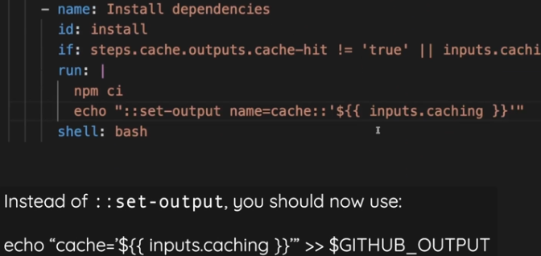

input.caching is either the default caching value or the caching value provided by the user

inputs:

caching:

description: 'Whether to caching dependencies'

required: false

default: 'true'

we can echo that input.caching value to produce as the step's output ($GITHUB_OUTPUT)

- name: Install dependencies

id: install

if: steps.cache.outputs.cache-hit != 'true' || inputs.caching != 'true'

run: |

npm ci

echo "cache='${{ inputs.caching }}'" >> $GITHUB_OUTPUT

shell: bash

And therefore, now here when we set the value for the overall action output, we reach out to this install step, now there to the cache output by using .outputs.cache,

**outputs**:

used-cache:

description: 'Whether the cache was used'

value: ${{ steps.install.outputs.cache }}

and that will make sure that the value provided here, which is of course the input value in this case, will be provided for this used cache output.

steps:

- ...

- name: Load & Cache dependencies

id: **cache-deps-step**

uses: ./.github/actions/cached-deps

with:

caching: "false"

- name: Output caching used?

run: |

echo "Cache used: ${{ steps.**cache-deps-step**.**outputs**.used-cache }}"

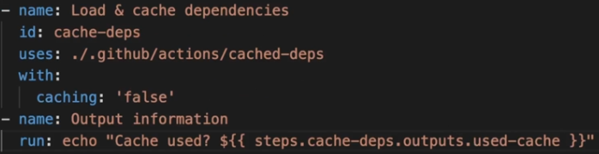

And this output of this action could now be used in the Workflow after using the action. Here, we could add a new step, output information, where I simply output some text. And to be precise, I will say cache used, and then add a dynamic expression where I reach out to my previous step by giving this step an ID, cache steps for example, and using steps.cache deps.outputs here. And then the output I defined, which in this case was used cache, so that is what I use here. And that will now print the output value of this custom action step here in this step. That's how it should work. Now we can create a new commit, added output and push this, and we should see that now our output is set and used as expected. So here for the linking step it did now finish our custom action step, and then in output information, it indeed does print that output from our own custom action step.

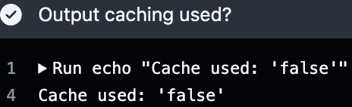

## 009 Custom JavaScript Actions - Getting Started

<https://docs.github.com/en/actions/tutorials/create-actions/create-a-javascript-action>

To speed up development, see GitHub Actions Node.js Toolkit: [**actions/toolkit**](https://github.com/actions/toolkit)

We'll build a custom action that will upload files to s3 bucket. We add a **name** and **description**. Now again, we add the **runs** key but unlike the composite action, this is **not** set to **composite**, but instead to **node**, and the versions of **node**. At this time, the latest version that Github Actions support is **node16**. Now, when you're using a JavaScript action, you also have to add a **main** field, pointing to the path of the file that should be executed for this custom action. And I'll also create a new file called **main.js**  in the same folder as the **action.yml** file, hence just the file name suffices.

.github/actions/**deploy-s3-js**/action.yml

name: 'Deploy to AWS S3'

description: 'Deploy a static website via AWS S3.'

runs:

using: 'node16'

main: 'main.js'

So we add the file name like this here, and this is the bare minimum we need to define a custom JavaScript action. And GitHub Actions will execute that **main.js** file, whatever the logic that might be in that file whenever this custom action is used in a Workflow step.

Now there are more fields you could add. For eg, pre and post scripts, for maybe extra setup or cleanup scripts.

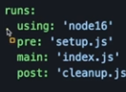

### Adding JavaScript Logic

**cd** .github/actions/deploy-s3-js

**npm init** -f

**npm i** @actions/core @actions/github @actions/exec

.github/actions/**deploy-s3-js**/main.js

const core = require("@actions/core");

const github = require("@actions/github");

const { exec } = require("@actions/exec");

async function run() {

core.notice("Hello from custom Javascript action!");

}

run();

.github/workflows/deploy.yml

jobs:

info:

runs-on: ubuntu-latest

steps:

- name: Run Custom JS GitHub Action

uses: ./.github/actions/deploy-s3-js

It's important to note that this **node_modules** folder will be a part of repo, it won't be ignored

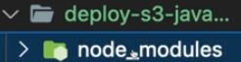

If we push our code now, we see this error:

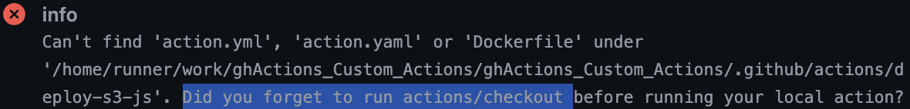

Why are we getting this error? I only have that custom action step. I never checkout my repo. I never get the code that includes the custom action definition. And that is required because it's a local action stored in this repo that we need.

If this was an action stored in some other repository, we could use it without checking out the code first.

But since it's part of this repo, we must add an extra step where we **checkout** code so that the action code is available.

.github/workflows/deploy.yml

jobs:

info:

runs-on: ubuntu-latest

steps:

- name: Get code

uses: actions/checkout@v3

- name: Run Custom JS GitHub Action

uses: ./.github/actions/deploy-s3-js

And with that, we can create a new commit. Check out code, and push this, and now we get a different error.



And the reason for this missing module file is that I'm ignoring all files that are inside of **dist** folder. Turns out that in my action's **node_modules** folder, this **uuid** dependency, which this error message is about, needs the **dist** folder so it's part of my local project, but not of the Git and GitHub repositories.

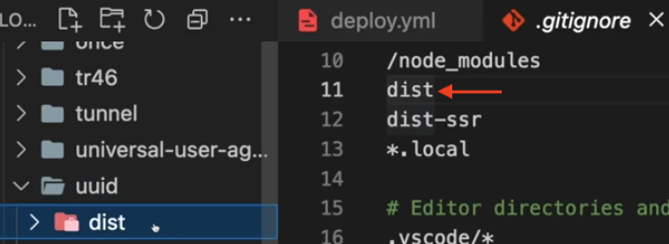

To fix this problem, I can make sure that only the root-level dist folder is ignored by putting a slash before it.

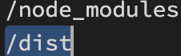

So if I run this now, I'll see the log message being generated

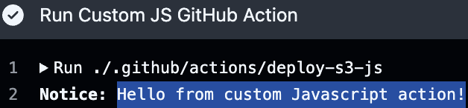

### Upload to S3

Create a new S3 bucket named custom-gh-action-hosting

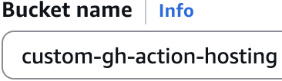

We're hosting a public website which we wanna allow public to access

So uncheck this:



And check this:

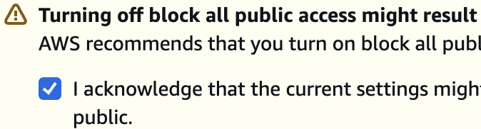

Go to [/s3/buckets/**custom-gh-action-hosting**](https://ap-southeast-2.console.aws.amazon.com/s3/buckets/custom-gh-action-hosting?region=ap-southeast-2&tab=properties&bucketType=general) settings > **Properties**, and enable **Static website hosting**



And set **index.html** as the default index document

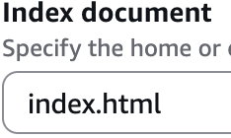

Go to **Permissions** tab, and go to **Bucket policy**, click **Edit**.

Copy the [Granting read-only permission to a public anonymous user](https://docs.aws.amazon.com/AmazonS3/latest/userguide/example-bucket-policies.html#example-bucket-policies-anonymous-user) and paste that into the policy field. Save changes.

{

"Version":"2012-10-17",

"Statement": [

{

"Sid": "PublicRead",

"Effect": "Allow",

"Principal": "*",

"Action": [

"s3:GetObject",

"s3:GetObjectVersion"

],

"Resource": "arn:aws:s3:::**custom-gh-action-hosting**/*"

}

]

}

And with this we can upload files into this bucket to serve a website, and the files that will be uploaded here are the files that are produced by this project when running this **build** script: 

So the files that are produced as part of our **build** job. These files which we upload here, these artifacts, that is what we would need to put into this bucket to have a website. But we're not going to do this manually but instead automatically and we're going to write our own custom action that does that because that's a great practice and even though there are actions in the marketplace to help us deploy to S3, writing our own action allows us to dive deeper into custom actions.

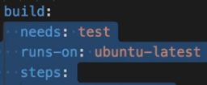

### Adding Action Inputs

So let's now start working on this JS action that will deploy the code that's produced by the **build** step in our workflow to the S3 bucket we created. And for that, in **main.js**, the first thing to do is that we get some **input** values, for info about the deployment target, the S3 bucket ARN, in order to move our code here.

.github/actions/deploy-s3-js/main.js

name: 'Deploy to AWS S3'

description: 'Deploy a static website via AWS S3.'

inputs:

bucket:

description: 'The S3 bucket name to deploy to.'

required: true

bucket-region:

description: 'The AWS region of the S3 bucket.'

required: true

default: 'us-east-1'

dist-folder:

description: 'Folder containing deployable website files.'

required: true

default: './dist'

runs:

using: 'node16'

main: 'main.js'

And now we can extract those input values in our JavaScript code here.

const core = require("@actions/core");

const github = require("@actions/github");

const exec = require("@actions/exec");

async function run() {

// 1) Get inputs values from action

const bucket = core.getInput("bucket", { required: true });

const bucketRegion = core.getInput("bucket-region", { required: true });

const distFolder = core.getInput("dist-folder", { required: true });

}

run();

So now, to upload my files, there are a few approaches. For eg, we can use the AWS SDK and call JavaScript methods. But instead, I'll use the **exec** package provided by GitHub, to run a command. And **exec** method needs a command as a string. Here, we could, for example, use **echo** because this will be executed in the regular shell of our runner. But here, I'll use the AWS CLI, which comes [pre-installed on Ubuntu images](https://github.com/actions/runner-images/blob/main/images/ubuntu/Ubuntu2404-Readme.md#cli-tools). And here we can use **aws S3 sync** command, which synchronizes a local folder to an S3 bucket. And then we can add some extra optional flags.



async function run() {

// 1) Get inputs values from action

const bucket = core.getInput("bucket", { required: true });

const region = core.getInput("bucket-region", { required: true });

const distFolder = core.getInput("dist-folder", { required: true });

// 2) Upload files to S3 bucket

const s3Uri = `s3://${bucket}`;

exec.exec(`aws s3 sync ${distFolder} ${s3Uri} --region ${region}`);

core.notice(`Deploying from ${distFolder} to ${s3Uri} in region ${region}`);

}

Before moving on, I also wanna show you this github package that we import. We're not using it, but it gives us access to **Octokit** client, that makes it easy to send requests to the GitHub REST API.

And we can also access **github.context** object:

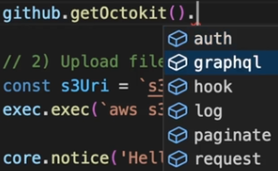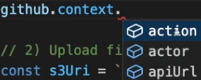

Now we'll add the region and bucket name for our [custom-gh-action-hosting](https://ap-southeast-2.console.aws.amazon.com/s3/buckets/custom-gh-action-hosting?region=ap-southeast-2&bucketType=general) bucket to our workflow.

09_Custom_Actions/.github/workflows/deploy.yml

build:

needs: test

runs-on: ubuntu-latest

steps:

...

- name: Build website

run: npm run build

- name: Upload artifacts

uses: actions/upload-artifact@v4

with:

name: dist-files

path: ./dist

deploy:

needs: build

runs-on: ubuntu-latest

steps:

- name: Get code

uses: actions/checkout@v3

- name: Get build artifacts

uses: actions/download-artifact@v5

with:

name: dist-files

path: ./dist

- name: Output contents

run: ls

- name: Deploy site

uses: ./.github/actions/deploy-s3-js

with:

bucket: "custom-gh-action-hosting"

dist-folder: "./dist"

bucket-region: "ap-southeast-2"

At the moment, our custom action main.js, would fail because in that actions code, we're trying to run **aws cli** command.

exec.exec(`aws s3 sync ...

Now this command tries to upload local files to s3 bucket. And we need permissions to interact with that bucket.

### Create access key

Click on your AWS account name in the top right corner, and then **Security credentials**, then **Create access key**

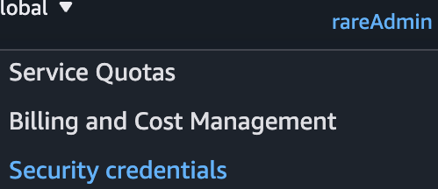 > 

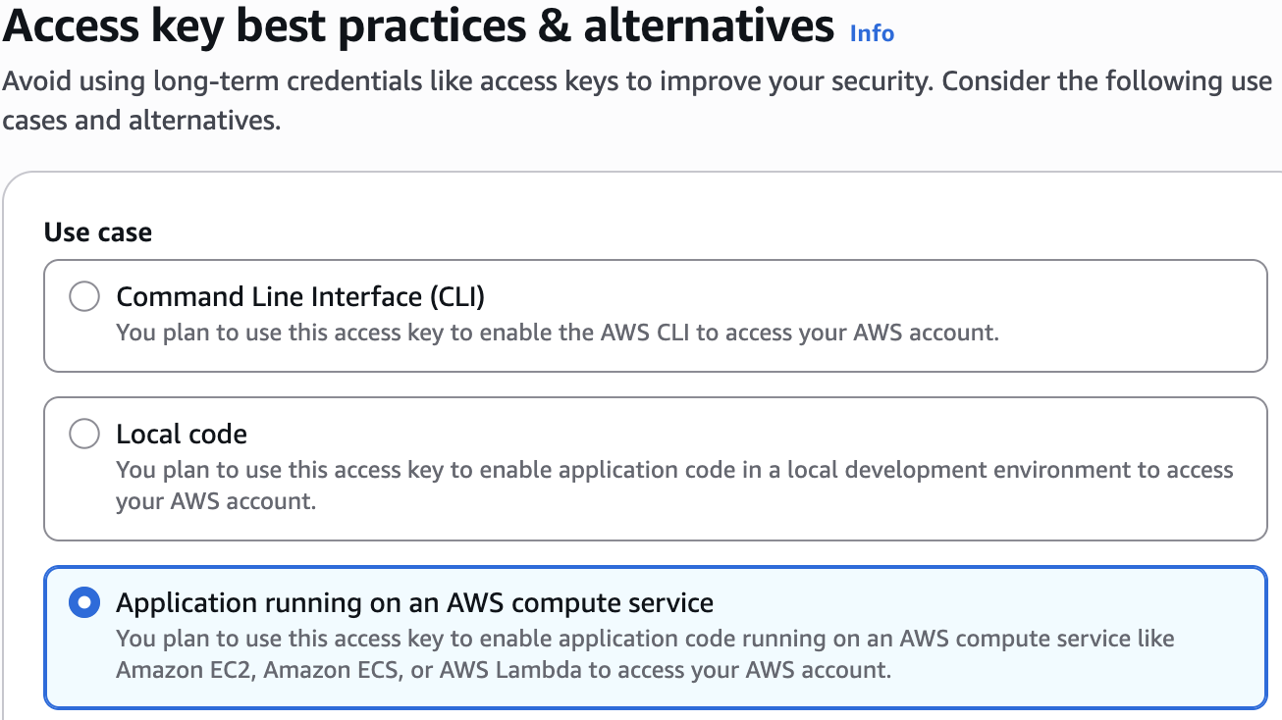

### Authenticate AWS CLI commands

The aws CLI looks for certain env variables with certain names and extract values from them. And if you set env variable is **AWS_ACCESS_KEY_ID** & **AWS_SECRET_ACCESS_KEY**, then AWS will use that for authenticating requests.



So we'll set these in Github Secrets ([settings/secrets/actions](https://github.com/qaiser110/ghActions_Custom_Actions/settings/secrets/actions))

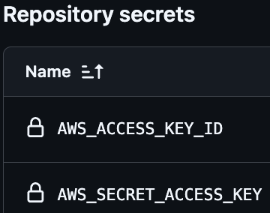

And now, we can add these secrets in our "Deploy site" step so that they're only available in just that step.

- name: Deploy site

uses: ./.github/actions/deploy-s3-js

env:

AWS_ACCESS_KEY_ID: ${{ secrets.AWS_ACCESS_KEY_ID }}

AWS_SECRET_ACCESS_KEY: ${{ secrets.AWS_SECRET_ACCESS_KEY }}

with:

bucket: "custom-gh-action-hosting"

dist-folder: "./dist"

bucket-region: "ap-southeast-2"

With that, this exec aws command will automatically pick up the auth env variables

exec.exec(`**aws s3 sync** ${distFolder} ${s3Uri} --region ${region}`);

And now, we can push the changes

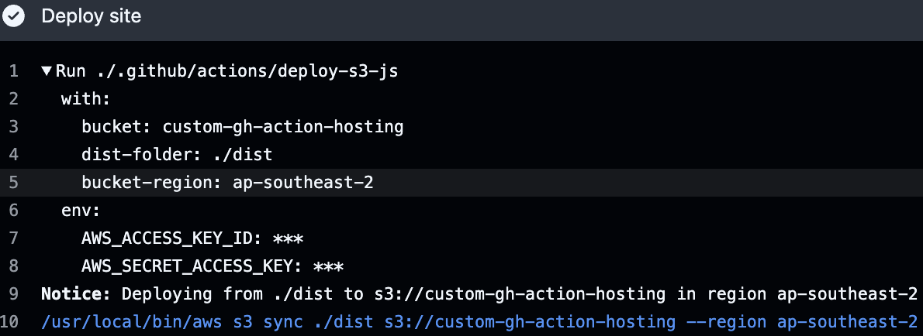

In our bucket's Properties tab, we'll find this url, pointing to our deployed website:



### Action Outputs

Now, I want to add an output to this action, to output the above dynamically generated website URL, so that we can visit this URL right from our GitHub Action's summary screen. To do that, we first have to register an output in action.

Remember, in **composite** action, we had a description and a value. The reason is that for the composite action we had all the logic within the **action.yml** and we needed to tell github where to get the value for this **output** from. With the custom JS action, it's different.

.github/actions/**deploy-s3-js**/action.yml

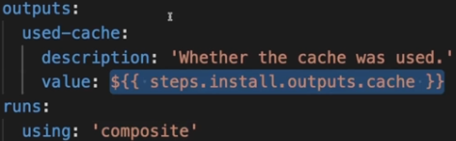

In JS action, we only add a **description**, not **value**. We just registered this **output** but we then set it from inside our code.

.github/actions/**deploy-s3-js**/action.yml

outputs:

deployed-url:

description: 'The URL of the deployed website.'

.github/actions/**deploy-s3-js**/main.js

const websiteUrl = `http://${bucket}.s3-website-${region}.amazonaws.com`;

core.setOutput("deployed-url", websiteUrl); // ::set-output

And with that this GitHub action will set the website URL as an output. This **output** can now be used in the workflow. So I'll add a new step after deploying the site where I just echo the output. And I need to access my **steps** context object and then to the previous **Deploy site** step. And for that I'll add an id to it, which you of course can do for steps with custom actions as well. And I'll name it deploy, the id, of course is up to you. And then here it's steps dot deploy dot outputs. And this must be **outputs** here, but then your output name. And in my case for this action the output name is **deployed-url**. So that is the output name we're accessing here.

.github/workflows/deploy.yml

- name: Deploy site

id: deploy-site

uses: ./.github/actions/deploy-s3-js

env:

AWS_ACCESS_KEY_ID: ${{ secrets.AWS_ACCESS_KEY_ID }}

AWS_SECRET_ACCESS_KEY: ${{ secrets.AWS_SECRET_ACCESS_KEY }}

with:

bucket: "custom-gh-action-hosting"

dist-folder: "./dist"

bucket-region: "ap-southeast-2"

- name: Output Website URL

run: |

echo "Live URL: ${{ steps.deploy-site.outputs.deployed-url }}"

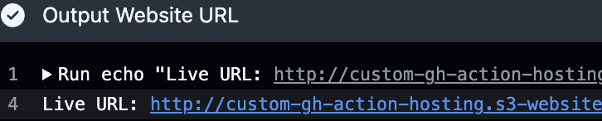

## Custom Docker Action

I'll add a new folder in this actions folder named **deploy-s3-docker** where I'll build the action that will upload the website code to S3, but we'll do this with a different language than JavaScript, and GitHub Actions only supports JS and Docker.

In **deployment.py** file, is the Python code for getting the deployment files that should be uploaded. And for uploading those files, we use a package called **boto3**, which is provided by AWS, which is the AWS SDK for Python.

.github/actions/**deploy-s3-docker**/deployment.py

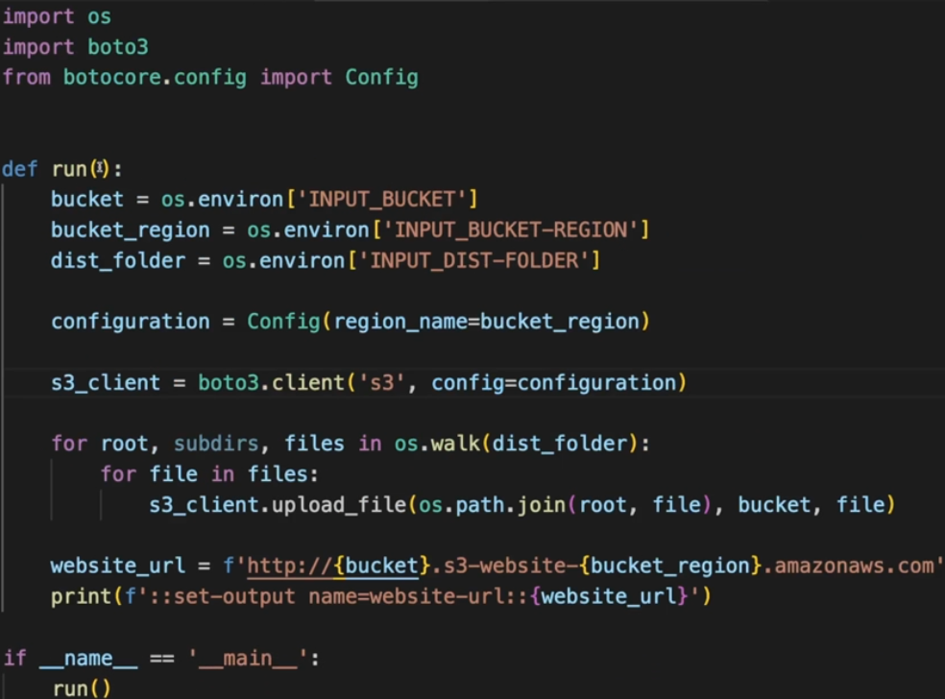

And the **Dockerfile** simply creates an environment where this code will run.

.github/actions/**deploy-s3-docker**/Dockerfile

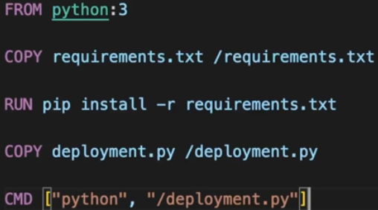

It creates a new container which gives us an environment where Python3 is installed. Then I copy this requirements.txt file into this container, and this simply specifies some packages that should be installed into the environment for the Python code to work, most importantly, this **Boto3** package

.github/actions/**deploy-s3-docker**/requirements.txt

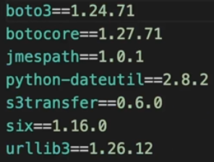

### Creating a Custom Docker Action

To create a Docker action based on that **Dockerfile** and the related code, I'll add a new **action.yml** file. We set **using** to **docker**. You must add the **image** key, and here, we have to provide the path to our **Dockerfile** that defines the container. Alternatively, you could also refer to some publicly available image here, for example, an image on Docker hub.

.github/actions/**deploy-s3-docker**/action.yml

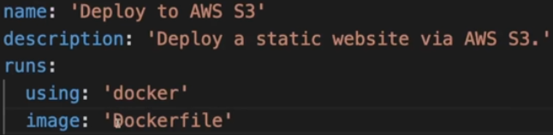

And just as the JavaScript action, this action needs some inputs, because it does the same thing as the JavaScript action. It uploads files to a S3 bucket and therefore we must inform the action about the bucket name, the region, and the folder that contains the files that should be uploaded.

For the inputs and outputs, the syntax is the same for Docker actions and JavaScript actions, so I'll copy both from our JS actions. Now, what's different is how we access those inputs in the code that's executed in the container and how we set outputs from inside that code.

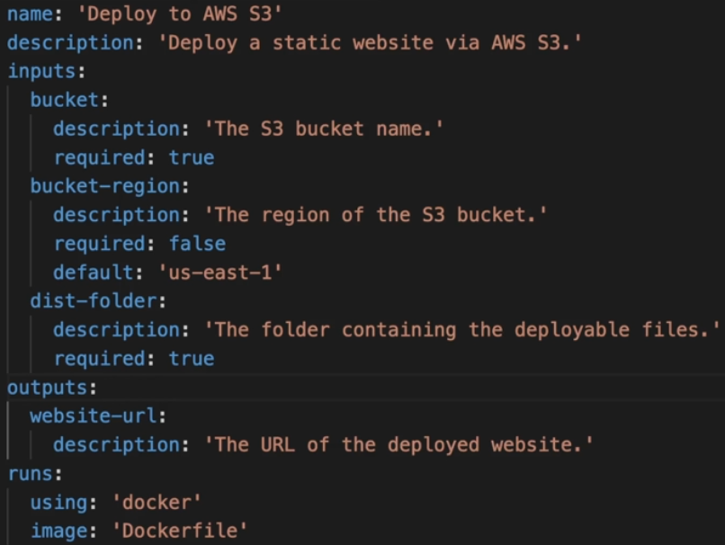

And you see how it works here in **deployment.py**. For accessing inputs, we're effectively using special environment variable, and these are env variables which are automatically generated by GitHub Actions.

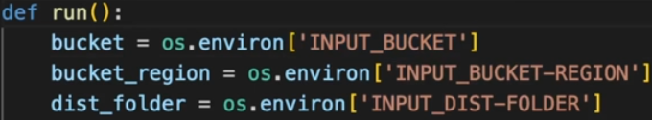

For every input, we specify in our **action.yml** file, GitHub Actions generates an environment variable that starts with **INPUT_** and then the name of your input also ALL CAPS. So our **bucket** input becomes **INPUT_BUCKET**. Our **bucket-region** input becomes **INPUT_BUCKET-REGION**. And it's a super easy way of extracting and using those input values in that code, by simply using these automatically set env variables. You could even add extra env variables in your Workflow file and we'll actually do that later. And those env variables would also be available here.

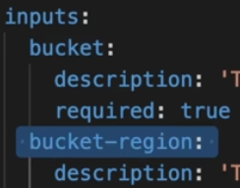

And when it comes to setting the **output**, the **website-url** output, that's done with a syntax that we know from earlier in the course with this **::set-output** command which is simply **print** to the console here.



And what's also important is that we still must set the access keys here, the AWS access keys. We still must set those because as before with the JavaScript action, of course by default, you would not be able to upload files to S3. By default, that's not allowed. But like the AWS CLI, this AWS SDK, which we're using here in our code, this boto3 package in the end automatically looks for environment variables with these names to authenticate those outgoing AWS requests. So if these environment variables exist here with valid values for your account, this upload file command will succeed. Otherwise, it would fail.

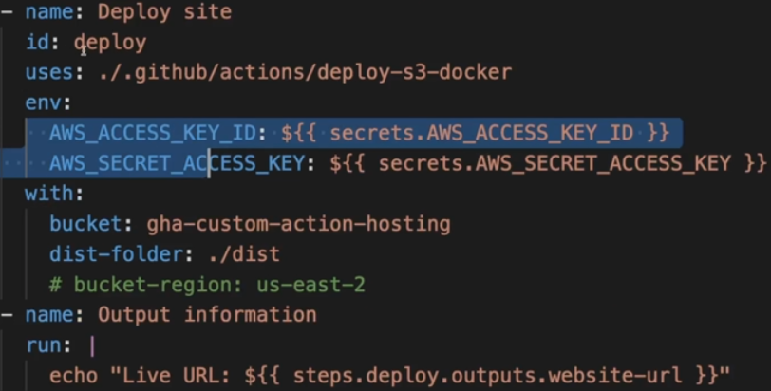

In this module, we created custom Actions that were stored in the same repository as our Workflow(s).

Alternatively, we could've stored the custom Actions in **separate repositories** (which therefore then only include the Action definition + code).

This is actually quite straightforward:

1. Create a new, local project folder which contains your action.yml file + all the code belonging to the action (Important: **Don't** put your action.yml file or code in a .github/actions folder or anything like that - just keep it directly on the root level of your created project!)
2. Add a local Git repository to your created project (via git init)
3. Create your commit(s) via git add and git commit
4. Create a GitHub repository and connect it to your local Git repository (via git remote add)
5. Add a tag via git tag -a -m "My action release" v1
6. Push your local code to the remote GitHub repository (via git push --follow tags)
7. Use your custom Action in any other Workflow (in any other project and repository) by referencing the repository which contains your action (e.g., my-account/my-action@v1)

If your custom Action is stored in a **public repository**, it can also be published to the GitHub Actions Marketplace as described here: <https://docs.github.com/en/actions/creating-actions/publishing-actions-in-github-marketplace#publishing-an-action>

Links

[Workflow syntax for GitHub Actions](https://docs.github.com/en/actions/reference/workflows-and-actions/workflow-syntax#onpushpull_requestpull_request_targetpathspaths-ignore)

[Filter pattern cheat sheet](https://docs.github.com/en/actions/reference/workflows-and-actions/workflow-syntax#filter-pattern-cheat-sheet)

[GitHub Actions Marketplace](https://github.com/marketplace?type=actions)

[Events that trigger workflows](https://docs.github.com/en/actions/reference/workflows-and-actions/events-that-trigger-workflows#pull_request)

Expressions

<https://docs.github.com/en/actions/reference/workflows-and-actions/expressions>

<https://docs.github.com/en/actions/concepts/workflows-and-actions/expressions>

Contexts

<https://docs.github.com/en/actions/reference/workflows-and-actions/contexts>

[Default Env Variables](https://docs.github.com/en/actions/reference/workflows-and-actions/variables#default-environment-variables)

Actions / Events

<https://docs.github.com/en/actions/using-workflows/events-that-trigger-workflows>

<https://docs.github.com/en/actions/reference/workflows-and-actions/events-that-trigger-workflows>

Storing-GitHub-credentials-Personal-Access-Tokens-with-Git-Credential-Manager

<https://github.com/GitCredentialManager/git-credential-manager>

tips

If you need to run multiple shell commands (or multi-line commands, e.g., for readability), you can easily do so by adding the pipe symbol (|) as a value after the run: key.

Like this:

...

run: |

echo "First output"

echo "Second output"

This will run both commands in one step.

VS Code Settings

<https://chatgpt.com/share/68e7faa8-cce0-800c-9b37-892c6208e489>

Better YAML Formatter

GitHub Actions Custom Highlight

YAML by Red Hat

<https://marketplace.visualstudio.com/manage/publishers/codecredible>

<https://code.visualstudio.com/api/working-with-extensions/publishing-extension#verify-a-publisher>

<https://github.com/qaiser110/VSCode-GitHub-Actions-Custom-Colors>

<https://stackoverflow.com/questions/79237876/overriding-theme-with-textmaterules-in-vs-code>

code --**list**-extensions | grep github-actions

code --**uninstall**-extension xxxxxxxxx

**chmod** +x github-actions-highlight/install.sh

cd github-actions-highlight

npm **install**

npm install -g vsce

npm run compile

vsce package

code --install-extension github-actions-custom-highlight-1.0.0.vsix

Developer: Reload Window

i have large github action yml files in my project using VS Code IDE

I want to have different colors for the step name, step command, step action, etc. How can I do that

Tell me step-by-step how to do this using Custom TextMate Scopes for YAML Files

### Method 1 - Edit Settings

~/Library/Application Support/Code/User/settings.json

"editor.tokenColorCustomizations": {

"textMateRules": [

{

"scope": "entity.name.tag.yaml",

"settings": {

"foreground": "#16acd5" // orange for step names

// "fontStyle": "bold"

}

},

{

"scope": "keyword.control.flow.yaml",

"settings": {

"foreground": "#ffaa00" // blue for run commands

}

}

]

},

### Method 2 - TextMate Grammar

**write your own custom TextMate grammar** for GitHub Actions YAML step-by-step.  
 This will let you give different colors (scopes) to things like:

* name:
* run:
* uses:
* even GitHub expressions like ${{ ... }}

## 🧩 Overview: What a TextMate Grammar Is

A **TextMate grammar** is a .tmLanguage.json or .plist file that defines regex-based **patterns** to assign syntax scopes to parts of text.  
 VS Code uses it for syntax highlighting.

You can:

* Write your own grammar.
* Load it as part of an extension (or in .vscode folder locally).
* Assign new **scopes** to keywords like run, name, uses, etc.

## 🧠 Step-by-step: Create a custom grammar for GitHub Actions YAML

### 1️⃣ Create the folder structure

Inside your project, add:

.vscode/

├── syntaxes/

│ └── github-actions.tmLanguage.json

└── package.json

### 2️⃣ Define your package.json

Tell VS Code to load your grammar when editing .yml or .yaml files under .github/workflows.

.vscode/syntaxes/github-actions.tmLanguage.json

.vscode/syntaxes/github-actions.tmLanguage.json

Instructions

Instructions

Let me try a different approach. The problem is that VS Code's built-in YAML grammar treats both run: and uses: as the same token type. Let me create a solution using a different method - using regex-based highlighting through a custom extension approach:

.vscode/github-actions-grammar.tmLanguage.json

{

"scopeName": "source.yaml.github-actions",

"fileTypes": [".github/workflows/*.yml", ".github/workflows/*.yaml"],

"patterns": [

{

"include": "source.yaml"

},

{

"match": "^(\\s*-\\s*run\\s*:)(.*)$",

"captures": {

"1": {

"name": "entity.name.command.run-keyword.github-actions"

},

"2": {

"name": "string.unquoted.command.run.github-actions"

}

}

},

{

"match": "^(\\s*-\\s*uses\\s*:)(.*)$",

"captures": {

"1": {

"name": "entity.name.command.uses-keyword.github-actions"

},

"2": {

"name": "string.quoted.double.action-reference.github-actions"

}

}

},

{

"match": "^(\\s*-\\s*name\\s*:)(.*)$",

"captures": {

"1": {

"name": "entity.name.section.name-keyword.github-actions"

},

"2": {

"name": "string.unquoted.step-name.github-actions"

}

}

},

{

"match": "\\$\\{\\{[^}]+\\}\\}",

"name": "variable.other.expression.github-actions"

}

]

}

.vscode/settings.json

{

"files.associations": {

"**/.github/workflows/*.yml": "yaml",

"**/.github/workflows/*.yaml": "yaml"

},

"editor.tokenColorCustomizations": {

"textMateRules": [

{

"scope": "support.type.property-name.yaml",

"settings": {

"foreground": "#FF6B6B",

"fontStyle": "bold"

}

},

{

"scope": "string.unquoted.yaml",

"settings": {

"foreground": "#FFE66D",

"fontStyle": "italic"

}

},

{

"scope": "string.quoted.double.yaml",

"settings": {

"foreground": "#79B8FF"

}

},

{

"scope": "entity.name.tag.yaml",

"settings": {

"foreground": "#F97583",

"fontStyle": "bold"

}

},

{

"scope": "constant.language.yaml",

"settings": {

"foreground": "#9ECBFF"

}

}

]

}

}

.vscode/package.json

Examples

Tab 8

name: Example GitHub Actions Workflow

on:

push:

branches: [main]

pull_request:

branches: [main]

jobs:

build-and-test:

runs-on: ubuntu-latest

steps:

- name: **Checkout code**

uses: actions/checkout@v4

- name: **Setup Node.js**

uses: actions/setup-node@v4

with:

node-version: "18"

cache: "npm"

- name: **Install dependencies**

uses: actionsnpm

- name: **Run tests**

run: npm test

- name: **Build application**

run: npm run build

- name: **Deploy to staging**

run: echo "Deploying to staging environment"

if: github.ref == 'refs/heads/main'

- name: **Custom command with parameters**

run: |

echo "Running custom script"

./scripts/deploy.sh --env production

echo "Deployment completed"

name: Lint + Test + Deploy

on:

push:

branches:

- main

pull_request:

branches:

- main

jobs:

lint_test_deploy:

**runs-on:** ubuntu-latest

**steps:**

**- name: Checkout repository**

uses: actions/checkout@v3

**- name: Set up Node.js**

uses: actions/setup-node@v3

with:

node-version: '18'

**- name: Install dependencies**

run: npm install

**- name: Run ESLint**

run: npm run lint

**- name: Run tests**

run: npm test

**- name: Deploy application**

if: github.ref == 'refs/heads/main' && success()

run: echo "Deploying application..."

# Add your deployment commands here

Tab 9

### Test on demand

name: Test on demand

on: workflow_dispatch

jobs:

test:

runs-on: ubuntu-latest

steps:

- name: **Get code**

uses: actions/checkout@v3

- name: **Install NodeJS**

uses: actions/setup-node@v3

with:

node-version: 18

- name: **Install dependencies**

run: npm ci

- name: **Run tests**

run: npm test

### Multiple Steps

name: Multiple Steps

on: push

jobs:

test:

runs-on: ubuntu-latest

steps:

- name: **Get code**

uses: actions/checkout@v3

- name: **Install NodeJS**

uses: actions/setup-node@v3

with:

node-version: 18

- name: **Install dependencies**

run: npm ci

- name: **Run tests**

run: npm test

deploy:

runs-on: ubuntu-latest

steps:

- name: **Get code**

uses: actions/checkout@v3

- name: **Install NodeJS**

uses: actions/setup-node@v3

with:

node-version: 18

- name: **Install dependencies**

run: npm ci

- name: **Build**

run: npm run build

- name: **Deploy**

run: echo "Deploying..."

context

### [Example usage of the env context](https://docs.github.com/en/actions/reference/workflows-and-actions/contexts#example-usage-of-the-env-context)

name: Hi Mascot

on: push

env:

mascot: Mona

super_duper_var: totally_awesome

jobs:

windows_job:

runs-on: windows-latest

steps:

**- run:** *echo 'Hi ${{ env.mascot }}' # Hi Mona*

**- run:** *echo 'Hi ${{ env.mascot }}' # Hi Octocat*

env:

mascot: Octocat

linux_job:

runs-on: ubuntu-latest

env:

mascot: Tux

steps:

**- run:** *echo 'Hi ${{ env.mascot }}' # Hi Tux*

### [Example usage of the job context](https://docs.github.com/en/actions/reference/workflows-and-actions/contexts#example-usage-of-the-job-context)

name: PostgreSQL Service Example

on: push

jobs:

postgres-job:

runs-on: ubuntu-latest

**services**:

**postgres**:

image: postgres

env:

POSTGRES_PASSWORD: postgres

options: --health-cmd pg_isready --health-interval 10s --health-timeout 5s --health-retries 5

**ports**:

# Maps TCP port 5432 in the service container to a randomly chosen port on host

- 5432

steps:

**- run:** *pg_isready -h localhost -p ${{* ***job.services.postgres.ports****[5432] }}*

**- run:** *echo "Run tests against Postgres"*

### [Example usage of the github context](https://docs.github.com/en/actions/reference/workflows-and-actions/contexts#example-usage-of-the-github-context)

name: Run CI

on: [push, pull_request]

jobs:

normal_ci:

runs-on: ubuntu-latest

steps:

- name: **Run normal CI**

run: echo "Running normal CI"

pull_request_ci:

runs-on: ubuntu-latest

if: ${{ github.event_name == 'pull_request' }}

steps:

- name: **Run PR CI**

run: echo "Running PR only CI"

### [Example usage of the vars context](https://docs.github.com/en/actions/reference/workflows-and-actions/contexts#example-usage-of-the-vars-context)

on:

workflow_dispatch:

env:

# Setting an *env variable* with the value of a configuration variable

env_var: ${{ vars.**ENV_CONTEXT_VAR** }}

jobs:

display-variables:

**name:** ${{ vars.**JOB_NAME** }}

# You can use configuration variables with the `vars` context for dynamic jobs

if: ${{ vars.**USE_VARIABLES** == 'true' }}

runs-on: ${{ vars.**RUNNER** }}

environment: ${{ vars.ENVIRONMENT_STAGE }}

steps:

- name: **Use variables**

run: |

echo "repository variable : **$REPOSITORY_VAR**"

echo "organization variable : **$ORGANIZATION_VAR**"

echo "overridden variable : **$OVERRIDE_VAR**"

echo "variable from shell environment : $env_var"

**env**:

**REPOSITORY_VAR**: ${{ vars.REPOSITORY_VAR }}

**ORGANIZATION_VAR**: ${{ vars.ORGANIZATION_VAR }}

**OVERRIDE_VAR**: ${{ vars.OVERRIDE_VAR }}

- name: **${{ vars.HELLO_WORLD_STEP }}**

if: ${{ vars.HELLO_WORLD_ENABLED == 'true' }}

uses: actions/hello-world-javascript-action@main

with:

who-to-greet: ${{ vars.GREET_NAME }}

inputs / outputs

### [Example usage of the inputs context in a reusable workflow](https://docs.github.com/en/actions/reference/workflows-and-actions/contexts#example-usage-of-the-inputs-context-in-a-reusable-workflow)

This example reusable workflow uses the inputs context to get the values of the build_id, deploy_target, and perform_deploy inputs that were passed to the reusable workflow from the caller workflow.

name: Reusable deploy workflow

on:

workflow_call: # This workflow can be called from other workflows

# use "workflow_dispatch" a manually triggered workflow

# https://docs.github.com/en/actions/using-workflows/reusing-workflows

inputs:

**build_id**:

required: true

type: number

deploy_target:

required: true

type: string

perform_deploy:

required: true

type: boolean

jobs:

deploy:

runs-on: ubuntu-latest

if: ${{ inputs.perform_deploy }}

steps:

- name: **Deploy build to target**

run: echo "Deploying build:${{ inputs.**build_id** }} to ${{ inputs.deploy_target }}"

### [Example usage of the jobs context](https://docs.github.com/en/actions/reference/workflows-and-actions/contexts#example-usage-of-the-jobs-context)

This workflow uses the jobs context to set outputs for the reusable workflow. Note how the outputs flow up from the steps, to the job, then to the workflow_call trigger. For more information, see [Reuse workflows](https://docs.github.com/en/actions/using-workflows/reusing-workflows#using-outputs-from-a-reusable-workflow).

name: Reusable workflow

on:

workflow_call:

# Map the workflow outputs to job outputs

outputs:

firstword:

description: "The first output string"

value: ${{ jobs.**example_job**.**outputs**.output1 }}

secondword:

description: "The second output string"

value: ${{ jobs.**example_job**.**outputs**.output2 }}

jobs:

**example_job**:

name: Generate output

runs-on: ubuntu-latest

# Map the job outputs to step outputs

**outputs**:

output1: ${{ **steps**.step1.outputs.firstword }}

output2: ${{ **steps**.step2.outputs.secondword }}

**steps**:

- id: step1

run: **echo** "firstword=hello" >> $GITHUB_OUTPUT

- id: step2

run: **echo** "secondword=world" >> $GITHUB_OUTPUT

### [Example usage of the needs context](https://docs.github.com/en/actions/reference/workflows-and-actions/contexts#example-usage-of-the-needs-context)

This example workflow has three jobs: a build job that does a build, a deploy job that requires the build job, and a debug job that requires both the build and deploy jobs and runs only if there is a failure in the workflow. The deploy job also uses the needs context to access an output from the build job.

name: Build and deploy

on: push

jobs:

build:

runs-on: ubuntu-latest

outputs:

build_id: ${{ steps.**build_step**.outputs.build_id }}

steps:

- name: **Build**

id: **build_step**

run: **echo** "build_id=$RANDOM" >> $GITHUB_OUTPUT

deploy:

needs: build

runs-on: ubuntu-latest

steps:

**- run:** *echo "Deploying build ${{ needs.build.outputs.build_id }}"*

debug:

needs: [build, deploy]

runs-on: ubuntu-latest

if: ${{ failure() }}

steps:

**- run***: echo "Failed to build and deploy"*

Failure Logs

### [Example usage of the runner context](https://docs.github.com/en/actions/reference/workflows-and-actions/contexts#example-usage-of-the-runner-context)

This example workflow uses the runner context to set the path to the temporary directory to write logs, and if the workflow fails, it uploads those logs as artifact.

name: Build

on: push

jobs:

build:

runs-on: ubuntu-latest

steps:

**- uses:** actions/checkout@v5

- name: **Build with logs**

run: |

mkdir ${{ runner.temp }}/build_logs

echo "Logs from building" > ${{ runner.temp }}/build_logs/build.logs

exit 1

- name: **Upload logs on fail**

if: ${{ failure() }}

uses: actions/upload-artifact@v4

with:

**name:** Build failure logs

path: ${{ runner.temp }}/build_logs

secrets

### [Example usage of the secrets context](https://docs.github.com/en/actions/reference/workflows-and-actions/contexts#example-usage-of-the-secrets-context)

This workflow uses [GitHub CLI](https://docs.github.com/en/actions/using-workflows/using-github-cli-in-workflows), which requires the GITHUB_TOKEN as the value for the GH_TOKEN input param:

name: Open new issue

on: workflow_dispatch

jobs:

open-issue:

runs-on: ubuntu-latest

permissions:

contents: read

issues: write

steps:

**- run:** *|*

gh issue --repo ${{ github.repository }} \

create --title "Issue title" --body "Issue body"

env:

GH_TOKEN: ${{ secrets.GITHUB_TOKEN }}

GITHUB_REPOSITORY: ${{ github.repository }}

Literals

## [Literals](https://docs.github.com/en/actions/reference/workflows-and-actions/expressions#literals)

name: Literals & Functions

env:

myNull: ${{ null }}

myBoolean: ${{ false }}

myIntegerNumber: ${{ 711 }}

myFloatNumber: ${{ -9.2 }}

myHexNumber: ${{ 0xff }}

myExponentialNumber: ${{ -2.99e-2 }}

myString: Mona the Octocat

myStringInBraces: ${{ 'It''s open source!' }}

env:

MY_ENV_VAR: ${{ github.ref == 'refs/heads/main' && 'value_for_main_branch' || 'value_for_other_branches' }}

- name: **Check if issue has label 'bug'**

run: |

if [[ "${{ github.event.issue.labels }}" != "" ]]; then

echo "${{ contains(github.event.issue.labels.*.name, 'bug') }}"

else

echo "No issue context available"

fi

Context

#### Event Context

You can use the event context to further control when jobs in your workflow will run.

For eg, this workflow will run when there is a **review_requested** on a **pull_request**, but the **specific_review_requested** **job** will only run when a review by **octo-team** is requested.

on:

pull_request:

types: [review_requested]

jobs:

specific_review_requested:

runs-on: ubuntu-latest

if: ${{ github.event.requested_team.name == 'octo-team'}}

steps:

- run: echo 'A review from octo-team was requested'

VSCode Workspace

### Option 1: Add Multiple Folders to One Workspace (Best Option)

Open one repo in VS Code (say, Repo A).

Then, add more repos and save as workspace:

File → Add Folder to Workspace...

File → Save Workspace As...

### Option 2: Use a Parent Folder Containing All Repos

If you keep your projects in a single parent folder (e.g., ~/projects/), you can:

mkdir ~/projects

cd ~/projects

git clone https://github.com/user/repo1.git

git clone https://github.com/user/repo2.git

Open the parent folder in VS Code:

code ~/projects

VS Code automatically detects each repo as a separate Git root.

### Option 3: Multi-root Workspace with Custom Settings

If your repos need **different settings, extensions, or environments**, you can define that in your workspace file:

{

"folders": [

{

"path": "repo1"

},

{

"path": "repo2"

}

],

"settings": {

"editor.formatOnSave": true,

"eslint.workingDirectories": ["repo1", "repo2"]

}

}

Save it as multi-repo.code-workspace, and open it using:

code multi-repo.code-workspace

## Tips for Power Users

* **Rename folders** in the workspace for clarity:  
  + Right-click → *Rename Folder in Workspace* (**does not rename the actual folder**).
* **Use GitLens** extension for advanced multi-repo control.

**Use Terminal profiles** to switch between repos quickly:  
  
cd repo1

git status

cd ../repo2

git pull